Quantitative Analysis of Wavelength Dependence of Thermal Perception

Akihisa Nomotoa, *, Yoshiichi Ozekib, Miyoko Oiwakeb, Ryo Hisayamac, Yutaro Ogawad, Mizuho Akimotoe, Shin-ichi Tanabee

a Center for the Built Environment, University of California Berkeley, California 94720-1839, USA

b Innovative Technology Laboratories, AGC Inc., Kanagawa 230-0045, Japan

c Nihon Sekkei Inc., Tokyo 163-1329, Japan

d Arup, Tokyo 102-0071, Japan

e Department of Architecture, Waseda University, Tokyo 169-8555, Japan

* Corresponding author.

Center for the Built Environment 390 Wurster Hall #1839, Berkeley, CA, USA

Tel: +1-510-642-4950

Fax: +1-510-643-5571

Email: [nomoto@berkeley.edu](mailto:nomoto@berkeley.edu)

# Keywords

Radiation, Wavelength, Thermal sensation, Thermal comfort, Thermoreceptor

# Abstract

In recent years, significant progress has been made in the development of materials that selectively reflect or absorb radiation in specific wavelength ranges. Previous studies have shown that the same intensity of radiation can produce different degrees of thermal perception depending on its wavelength. This difference is thought to be the optical properties of the skin. However, these findings have not been quantitatively verified yet. The purpose of this study is to quantitatively analyze the effects of radiation of different wavelength ranges on thermal sensation. We conducted a human subject experiment and discovered that far-infrared radiation causes a warmer and more uncomfortable sensation than near-infrared radiation. To interpret these results, we developed a new mathematical model that predicts thermal perception caused by radiation of different wavelengths. The model is based on a heat diffusion equation within the skin and considers the optical properties of the skin to simulate thermoreceptor activities in response to given spectral irradiances. Our model explained the observed phenomenon in our and previous experiments, where the same intensity of radiation but at different wavelengths can produce different degrees of thermal perception, in terms of physiological mechanisms. Additionally, the model revealed a hierarchy in thermal sensation, with far-infrared radiation being perceived as the warmest, followed by mid-infrared, visible, and near-infrared radiation. These findings are crucial for designing materials that selectively reflect or absorb radiation in specific wavelength ranges, and for developing heaters that provide efficient heating with low energy consumption.

# Implications and impacts

* This study provides a quantitative analysis of the skin’s thermal sensitivity to different wavelengths.
* The skin experiences increasingly stronger thermal sensations in the following order: far-infrared, mid-infrared, visible, and near-infrared radiation when exposed to the same level of intensity.
* The insights gained from this research are instrumental for the development of materials that selectively reflect and absorb radiation in specific wavelength ranges, as well as for designing heaters that provide energy-efficient heating to the human body.

# Nomenclature

*C*s*, C*d : static and dynamic coefficients (2 [K-1s-1], 56 [K-1])

*I* : impulse frequency [Hz]

*Kλ* : spectral absorption coefficient of the skin [m-1]

*PSI* : psychosensory intensity [-]

*Rλ* : spectral reflectance on the skin surface [-]

*Sλ* : spectral scattering coefficient of the skin [m-1]

*T* : temperature [°C]

*T*a: air temperature [°C]

*T*b,ir : blackbody temperature at irradiated area [°C]

*T*cr: core temperature [°C]

*T*mrt : mean radiant temperature [°C]

*T*sk: skin temperature [°C]

*T*wr: temperature at warm receptors [°C]

*T*wr,ref: reference temperature at warm receptors (33.0 [°C])

*TS* : thermal sensitivity [K-1]

*h*c: convective heat transfer coefficient [W/(m2･K)]

*k* : thermal conductivity of the skin (0.25 [W/(m･K)])

*q*ir*,λ* : heat flux by spectral irradiance [W/m2]

*q*ir,lw : heat flux by longwave irradiance [W/m2]

*q*ir,sw : heat flux by shortwave irradiance [W/m2]

*t* : time [s]

*x* : distance [m]

*σ* : Stefan–Boltzmann constant (5.67×10-8[W/(m2･K4)])

*ρc*  : heat capacity of the skin (4.30×106 [J/(m3･K)])

*ε* : emissivity of the skin surface in the long-wavelength range (0.97 [-])

# Suffix

*i* : wavelength range (A, B, or C)

# Introduction

In recent years, significant progress has been made in the development of materials that selectively reflect or absorb wavelengths within a specific range. For example, infrared cut glass, which is mainly used in buildings and automobiles, transmits visible rays but selectively blocks infrared and ultraviolet rays, thus reducing the thermal discomfort caused by direct solar radiation transmitted through the glass. To develop such technologies, surveys and experiments have been conducted on the effects of radiation at different wavelengths on thermal perception. These experiments have shown that the same intensity of radiation can provide different degrees of thermal perception depending on its wavelength [1–7].

Given an extremely complex radiant environment created in buildings and automobiles where these new technologies are introduced, it is challenging to evaluate occupants’ thermal sensation by using the conventional thermal comfort evaluation indices that do not consider the wavelength characteristics of solar radiation, human skin, and clothing. Predicted mean vote (PMV) [8] and standard new effective temperature (SET*) [9], which are typically used as thermal comfort evaluation indices in building spaces, evaluate occupants’ thermal comfort based on six parameters: clothing insulation, human metabolic rate, air temperature, relative humidity, air velocity, and mean radiant temperature in the ambient environment. Mean radiant temperature is a hypothetical uniform ambient temperature that radiates the same amount of radiant heat as received by the human body from the surrounding environment in an actual non-uniform radiation environment [10]. It enables the evaluation of non-uniform thermal environments, such as the difference in temperature of the indoor walls. However, it is assumed that the emissivity of wall surfaces and the human body is unity, which is generally difficult to apply in a solar radiation environment. OUT_SET* [11] and Solar Cal [12] make it possible to approximate the radiant heat exchange in a solar radiation environment by dividing the radiation into two categories—short wavelength and long wavelength—and providing the radiative properties of the skin and clothing for each type of radiation. However, to develop materials that selectively reflect or absorb only certain wavelengths, as described above, and to evaluate the effects of these materials on occupants’ thermal perception, it is necessary to differentiate thermal sensations of radiation more accurately across various wavelength ranges.

Several researchers have experimentally clarified the effects of radiation of different wavelength ranges on thermal sensation and comfort. Narita et al. [1,2] conducted an experiment to determine the range of solar radiation wavelength that had the greatest effect on thermal sensation. They conducted a paired comparison experiment where the backs of subject’s hands were irradiated with a combination of two out of three different types of radiation: visible (0.30–0.84 μm), near-infrared (0.80–1.35 μm), and mid-infrared (1.70–2.30 μm). This research found that mid-infrared radiation produced the strongest thermal sensation on the skin, and similar results were confirmed on the forearm, thigh, and neck [3]. They also studied the difference in skin temperature rise due to each type of radiation, focusing on human thermal physiology [6]. Matsui et al. [5] and Hirn et al. [7] investigated thermal sensation on the skin irradiated with infrared radiation of different wavelength ranges, including far-infrared. Matsui et al. [5] performed a paired comparison experiment where the subject’s hands were irradiated with a combination of two out of three different types of radiation: 0.72–2.7 μm, 1.5–4.8 μm, and 6.0–20.0 μm. They experimentally clarified that radiation in the wavelength range of 1.5–4.8 µm and 6.0–20.0 µm generated warmer thermal sensation on the skin than radiation in the wavelength range of 0.72–2.7 µm, even at the same irradiation intensity; further, they reported that longer wavelengths (> 2 μm) caused warmer thermal sensation on the skin than shorter wavelengths (< 2 μm). Hirn et al. [7] conducted a human subject experiment on the effect of different wavelengths in the infrared range on thermal sensation and comfort. The subjects were irradiated with two different wavelengths—near-infrared and far-infrared (peak wavelengths of 1.2 μm and 8 μm, respectively)—under two irradiation intensities (100 W/m2 and 200 W/m2) and two thermal environments (16 °C and 22 °C). They reported that far-infrared radiation caused warmer whole-body thermal sensation than near-infrared radiation especially when the subjects were in thermal neutral conditions (ambient temperature of 16 °C and irradiation intensity of 200 W/m2, ambient temperature of 22 °C and irradiation intensity of 100 W/m2).

Several researchers [2,5,7] consider that these wavelength dependences of thermal perception can be attributed to the skin’s radiative properties. The reflectance at the surface of the human skin and the transmission and absorption properties inside the skin vary greatly depending on the wavelength [13–17]. For example, in the near-infrared range of 0.78–1.40 μm (classified according to the CIE International Glossary of Illumination [18]), the amount of radiation entering the skin is small because the skin reflectance in that range is higher than that in the other wavelength ranges [13,14,16]. In addition, in the near-infrared range, the transmittance inside the skin is relatively high [13,14,16]; therefore, it is considered that the radiation is converted into heat at a greater depth than that of the thermoreceptors, resulting in less stimulation. In contrast, in the mid-infrared and far-infrared ranges above 2.0 μm, the reflectance and transmittance of the skin are very small [13,14,16], and most of the radiation might be converted to heat near the surface of the skin; consequently, the activity of the thermoreceptors is considered to be large. However, these considerations have not been quantitatively verified.

The purpose of this study is to quantitatively analyze the effects of radiation of different wavelength ranges on thermal sensation. This article proceeds in five steps:

* **Human subject experiment.** We describe our human subject experiment on thermal sensation and comfort caused by infrared radiation of different wavelengths.
* **Model development.** We describe a new mathematical model to predict thermal perception affected by radiation of different wavelengths.
* **Quantitative analysis.** We simulate our human subject experiment and that conducted by the previous studies using the newly developed model to quantitatively interpret the effects of radiation of different wavelength ranges on thermal perception.
* **Standardization.** We present the wavelength dependence of thermal perception at every 0.1 μm interval in the range of 0.3–20.0 μm.
* **Discussion.** We discuss the characteristics of far-infrared radiation and the limitations of the model.

# Human subject experiment on skin thermal sensation and comfort caused by infrared radiation of different wavelengths

We conducted human subject experiments to clarify thermal sensation and comfort caused by infrared radiation of different wavelength ranges. Two experiments—a paired comparison experiment combining two types of radiation in three different wavelengths with almost the same intensity (Experiment 1) and quantification of thermal sensitivity to each radiation in the three different wavelength ranges through an adjustment method (Experiment 2)—were conducted.

Fig. 1 shows the experimental configuration. The experiment was conducted from March 10 to 12, 2021, in a climate chamber (3.6 m × 2.7 m × 2.3 m) at Waseda University. The subjects were 20 healthy young Japanese individuals (10 men and 10 women). The anthropometric data of the subjects were investigated before the start of the experiment, and these are listed in Table 1. The subjects participated in the experiment in pairs, and an experimenter accompanied the two subjects in the chamber. This experiment was approved by the Committee for Ethics Concerning Research with Human Subjects of Waseda University (Approval No. 2020-365).



Fig. . Experimental configuration: (a) Plan view of the climate chamber and (b) photo taken during the experiment.

Table Anthropometric data of the subjects.

|  |  |  |  |  |  |  |  |  |  |  |
| --- | --- | --- | --- | --- | --- | --- | --- | --- | --- | --- |
|  | Sample size [-] | Age [-] | | | Height [m] | | | Weight [kg] | | |
| Male | 10 | 23.2 | ± | 1.2 | 1.73 | ± | 0.07 | 64.9 | ± | 9.2 |
| Female | 10 | 22.4 | ± | 1.0 | 1.59 | ± | 0.04 | 49.7 | ± | 6.4 |
| All subjects | 20 | 22.8 | ± | 1.2 | 1.66 | ± | 0.09 | 57.3 | ± | 10.9 |

## Paired comparison experiment (Experiment 1)

The subjects were irradiated with a combination of two out of the following three wavelength ranges:

* **Radiation A**: near-infrared range (0.8–1.4 µm)
* **Radiation B**: mid- to far-infrared range (2.3–5.0 µm)
* **Radiation C**: far-infrared range (2.3 µm and above)

The irradiation was applied to backs of their left and right hands through a circular irradiation port with a diameter of 6 cm. They rated the relative thermal sensation caused by each pair of radiation types using pairwise comparison.

### Experimental conditions

The thermal environment in the chamber was controlled so that the subjects were in a thermally neutral state in a sitting position. The thermal environmental parameters in the chamber were measured at 10 min intervals using an amenity meter (Delta OHM, HD32.3). The average air temperature was recorded at 25.3 °C, relative humidity at 51%, mean radiant temperature at 25.0 °C, and air velocity at 0.0 m/s. The subjects were asked to wear a specified clothing ensemble (face mask, T-shirt, underwear, short pants, and socks) to standardize clothing insulation. The clothing insulation of this ensemble was measured by using a thermal manikin in accordance with ISO 9920 (2007) [19]; the measured value for the whole body was 0.56 clo.

Fig. 2 shows an inner view of the experimental equipment. In this experiment, an artificial solar lamp (SERIC, XELIOS XG-500B) and a ceramic heater with high emissivity (SAKAGUCHI E.H VOC CORP., average emissivity of 0.97 in the wavelength range of 2 – 25 µm) were used as the radiation sources. Radiation A (0.8–1.4 µm) and B (2.3–5.0 µm) were created by combining these sources with special filters ([Optical Coatings Japan](https://www.ocj.co.jp/en/tabid/89/Default.aspx), custom-made) that transmit radiation in only certain wavelength ranges. No filter was used for Radiation C (2.3 µm and above). To eliminate the influence of visual effects on the experimental results, the equipment was designed so that the subjects could not see the radiation sources. This equipment was made of stainless steel, and its inner surface was mirror-finished to minimize the effect of radiation from it on the experimental results.

Fig. 3 shows the relative spectral irradiance of each radiation source and the spectral transmittance of the filters. We measured the spectrum of Radiation A, while the spectra of Radiation B and C were estimated based on Planck’s law using the surface temperature and spectral emissivity of the ceramic heaters because it was very difficult to measure the spectral irradiance in the infrared range (Fig. 3a). Both filters had extremely high spectral transmittance in their targeted wavelength ranges (Fig. 3b).

The blackbody temperature was measured using a heat flow sensor (ETO DENKI, M55A) at the same position as the irradiated area (back of the hand) before the experiment so that the amount of sensible heat loss under each condition was equal. The outputs of the radiation sources were adjusted so that the black body temperatures at different points were 37.0 °C. To double-check the irradiance of each radiation, long- and short-wavelength radiation for each condition was measured using a radiometer (EKO, MR-60). This device can measure shortwave (0.285–2.800 µm) and longwave (3–50 µm) radiation in upward and downward directions. The measurement results are presented in Table 2. The heat flux by downward total irradiance was almost the same for each condition, although the value for Radiation B was slightly smaller than those for Radiation A and C at constant blackbody temperature. The main reason for this might be the measurement accuracy and range of the radiometer used in this study. It might be difficult for it to measure radiation in 2.8 µm to 3.0 µm, which is the gap between the long- and short-wavelength measurement ranges. Consequently, Radiation B which has a higher intensity in that range may become smaller than others. Similarly, some of the irradiance of Radiation C might not be measured. The heat flux by irradiance *qir*[*i*] in each wavelength range (A, B, or C) that the skin receives is calculated as described in Eq. (1) by adding the difference between the measured downward longwave irradiance *q*ir,lw[*i*] and radiosity from the skin surface *εσ*(*T*sk[*i*] + 273.15) 4 to the measured downward shortwave radiation *q*ir,sw[*i*], where *i* represents each wavelength range (A, B, or C), *ε* is the emissivity of the skin surface (0.97[-]) and *σ* is Stefan–Boltzmann constant (5.67 × 10−8 [W/m2K4] ). The calculated irradiance in each wavelength range was approximately 200 W/m2.

|  |  |  |
| --- | --- | --- |
|  |  | () |

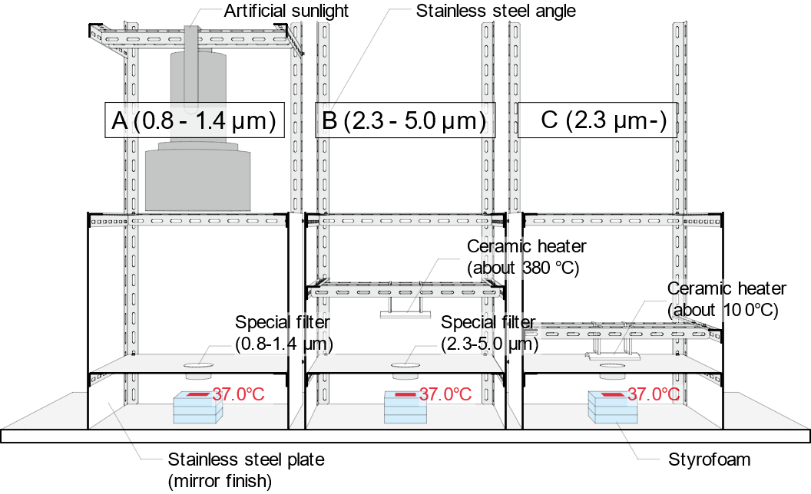

Fig. . Inner view of the experimental equipment: This setup provides the same intensity of irradiation in different wavelength ranges. The apparatus includes an artificial sunlight source and a high-emissivity ceramic heater, producing Radiation A (0.8–1.4 µm) and B (2.3–5.0 µm) through the custom filters. Radiation C (2.3 µm and above) is generated without any filter. The outputs of the radiation sources were adjusted to maintain the black body temperature at the irradiated areas at 37.0 °C.

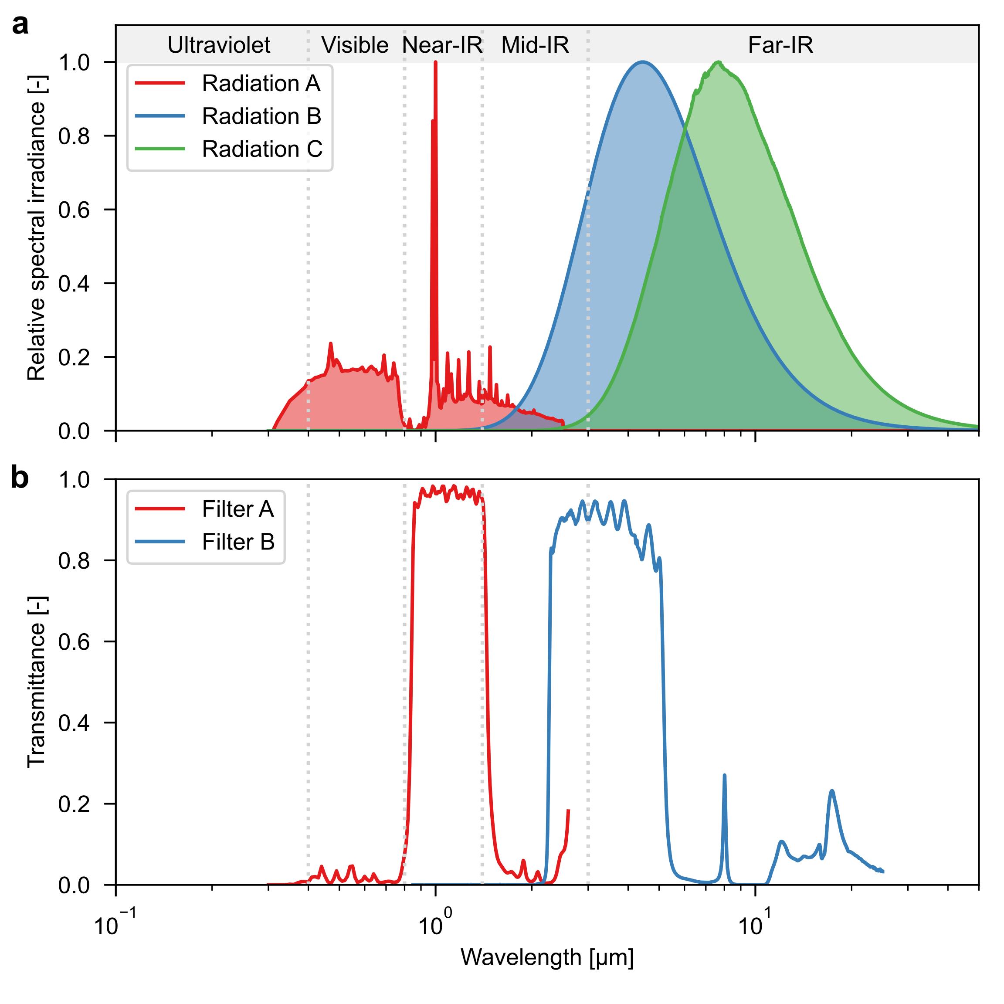

Fig. . Irradiation conditions: (a) Relative spectral irradiance of each radiation source and (b) spectral transmittance of filters. The spectrum of Radiation A is measured, and those of Radiation B and C are estimated based on Planck's law using the measured surface temperature and spectral emissivity of the ceramic heaters (Panel a). Both filters have high spectral transmittance in specific wavelength ranges (Panel b).

Table Measured values at the irradiated areas.

|  |  |  |  |  |  |  |  |  |  |  |
| --- | --- | --- | --- | --- | --- | --- | --- | --- | --- | --- |
|  |  | A (0.8–1.4 µm) | | | B (2.3–5.0 µm) | | | C (2.3 µm and above) | | |
| Blackbody temperature | [°C] | 37.0 | ± | 0.1 | 37.0 | ± | 0.2 | 37.0 | ± | 0.1 |
| Downward shortwave irradiance (0.285–2.800 µm) | [W/m2] | 228 | | | 48 | | | 43 | | |
| Downward longwave irradiance (3–50 µm) | [W/m2] | 478 | | | 622 | | | 653 | | |
| Downward total irradiance | [W/m2] | 706 | | | 670 | | | 696 | | |
| Irradiance in each wavelength range | [W/m2] | Calculated by Eq. (1) | | | | | | | | |

### Experimental procedure and measurements

The subjects gathered in the climate chamber approximately 20 min before the start of the experiment, changed into the designated clothing, and entered the climate chamber after their height and weight were measured. After entering the climate chambers, the subjects were asked to remain in a seated resting position for 35 min, and then the paired comparison experiment was conducted three times (A and B, B and C, A and C) every 15 min in random order.

Fig. 4 shows the survey questionnaire. To assess the subject’s thermal states during the experiment, they were asked to rate their whole-body thermal sensation before irradiation at 0.5 intervals on a 7-point scale (Fig. 4a) in accordance with ASHRAE standard 55 (2017) [20]. Immediately after the irradiation, they were asked to rate which radiation type produced a warmer or more comfortable thermal sensation at 0.5 intervals on a 7-point scale (Fig. 4b and Fig. 4c).



Fig. . Survey questionnaire: (a) Thermal sensation for the whole body, (b) relative thermal sensation for the irradiated area, and (c) relative thermal comfort for the irradiated area.

## Quantification of thermal sensitivity to each radiation (Experiment 2)

Due to the non-proportional scale of the survey questionnaire used in Experiment 1, numerically examining thermal sensitivity to radiation in each wavelength range is challenging. Therefore, 15 min after completing Experiment 1, we conducted Experiment 2 to quantify this thermal sensitivity using an adjustment method. This method is a psychophysical technique in which subjects or experimenters adjust a variable stimulus to match a constant or standard stimulus. The experimental conditions were identical to those used in Experiment 1.

In Experiment 2, the subject’s left and right hands were irradiated with a combination of Radiation A and B or Radiation A and C. The experiment was conducted twice (A and B, A and C) every 15 min in random order. The experimenter adjusted the intensity of Radiation A until the subjects felt a similar thermal sensation on both hands, and the blackbody temperature *T*b,ir at the irradiated area was measured. Thermal sensitivity to radiation in each wavelength range, denoted as *TS*, was calculated as the inverse of the increase in blackbody temperature due to irradiation, a relationship detailed in Eq. (2).

|  |  |  |
| --- | --- | --- |
|  |  | () |

## Experimental results

### Thermal sensation and comfort of the whole body

Although the subjects felt slightly cool before irradiation, the mean values of the thermal sensation votes of all subjects were within the recommended thermal comfort zone of category B in ISO 7730 (2005) [21] (−0.5 < thermal sensation vote < 0.5) under all conditions. The maximum difference between the mean values of the whole-body thermal sensation votes for each condition was 0.2, indicating that the influence of the differences in thermal sensation under each condition on the experimental results described below is small.

### Thermal sensation and comfort of the irradiated area (Experiment 1)

Fig. 5 shows the relative thermal sensation and comfort for the backs of the hands when the two types of radiation are compared. Although the intensities of Radiation B and C were slightly lower than that of Radiation A in the irradiated areas, they were perceived as hotter and more uncomfortable than Radiation A. This result is attributed to the optical characteristics of the skin and is consistent with the results of a previous study [7], which showed that far-infrared radiation caused warmer thermal sensations on the skin than near-infrared radiation. Further, Radiation C generated warmer thermal sensations and discomfort at the back of the hand than Radiation B. This result implies that far-infrared radiation, especially in the range of 5 µm or longer, may cause warmer thermal sensation and more discomfort at the back of the hand than far-infrared radiation of wavelength shorter than 5 µm. However, clarifying the cause is difficult. The intensity of Radiation C was slightly higher than that of Radiation B at the receiving level, which might have contributed to this difference.

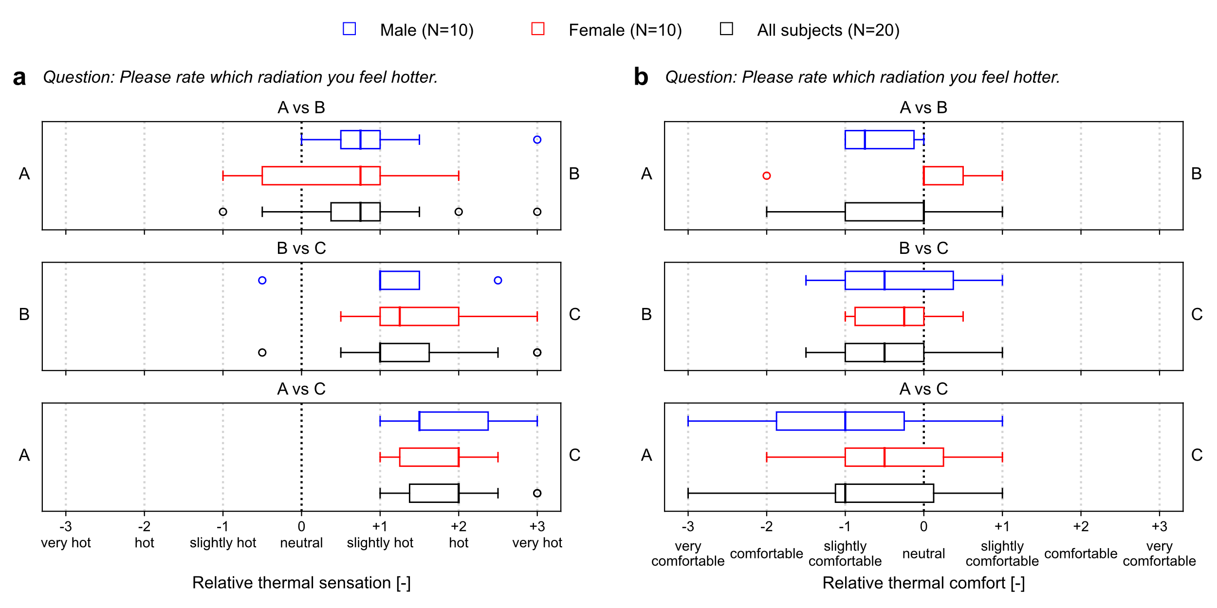

Fig. . Subjective response for the backs of the hands when comparing the two types of radiation: (a) Relative thermal sensation vote and (b) relative thermal comfort vote. The data closer to the left or right labels (A, B, or C) in the panels indicate the radiation perceived as hotter or more comfortable in each pair of comparisons.

### Thermal sensitivity to radiation in each wavelength range (Experiment 2)

Table 3 shows the blackbody temperature under each condition when the subjects sensed similar sensations on the backs of their hands. The blackbody temperature for Radiation A was higher in males than in females, but the difference was not significant. Regarding the mean values for all subjects, the subjects felt a thermal sensation on the backs of the left and right hands to be similar when the blackbody temperature with Radiation B was 36.9 °C and that with Radiation A was 39.4 °C. When the blackbody temperature for Radiation A reached 40.9 °C and 37.2 °C for Radiation C, they sensed similar thermal sensations on the backs of their left and right hands.

Table 4 lists the ratios of blackbody temperature rise and thermal sensitivity for radiation in each wavelength range. Based on Table 3, the ratios were calculated for the blackbody temperature rise, which was subtracted from the measured mean radiant temperature of the surrounding environment (25.0 °C). When the value for Radiation A was set to 1.00, the ratio of the blackbody temperature rise for Radiation B and C, at which the stimulations generated by the radiation were sensed to be similar, was A : B: C = 1.00: 0.82: 0.76. The inverse of this temperature rise was defined as thermal sensitivity, and its ratio for each wavelength range was calculated to be A: B: C = 0.76: 0.93: 1.00. Thus, the data quantitatively indicates that the intensity of thermal sensation induced by the radiation follows the order of A, B, and C.

Table Blackbody temperature when subjects felt similar thermal sensations [°C].

|  |  |  |  |  |  |  |  |  |  |  |
| --- | --- | --- | --- | --- | --- | --- | --- | --- | --- | --- |
| Ensemble |  | A (0.8–1.4 µm) | | | B (2.3–5.0 µm) | | | C (2.3 µm and above) | | |
| A and B | Male (N=10) | 40.8 | ± | 6.1 | 36.9 | ± | 0.4 |  | | |
| Female (N=10) | 37.8 | ± | 1.2 | 36.9 | ± | 0.4 |
| All subjects (N=20) | 39.4 | ± | 4.9 | 36.9 | ± | 0.4 |
| A and C | Male (N=10) | 41.8 | ± | 6.4 |  | | | 37.2 | ± | 0.6 |
| Female (N=10) | 40.1 | ± | 4.5 | 37.1 | ± | 0.6 |
| All subjects (N=20) | 40.9 | ± | 5.6 | 37.2 | ± | 0.6 |

Table Ratios of blackbody temperature rise and thermal sensitivity for radiation in each wavelength range.

|  |  |  |  |
| --- | --- | --- | --- |
|  | A (0.8–1.4 µm) | B (2.3–5.0 µm) | C (2.3 µm and above) |
| Ratio of blackbody temperature rise [-] (N=20) | 1.00 | 0.82 | 0.76 |
| Thermal sensitivity ratio [-] (N=20) | 0.76 | 0.93 | 1.00 |

# Development of a prediction model for psychosensory intensity affected by radiation of different wavelengths

In this study, we developed a new mathematical model to predict psychosensory intensity (PSI) affected by radiation of different wavelengths. The model is based on the previous PSI model proposed by de Dear et al. [24] and further updates the equations to simulate the effects of wavelengths on PSI of radiant heat using spectral skin data provided by Terada et al. [13]. The model is coded in Python-3 and is available at <https://github.com/AkihisaNomoto/thermoreceptormodel>.

## General properties of thermoreceptors

Fig. 6 shows the general properties of thermoreceptors [22]. It has been reported [22] that the skin of the human body has cold receptors at a depth of 0.15–0.17 mm and warm receptors at a depth of 0.3–0.6 mm below the surface. When thermoreceptors receive a thermal stimulus, they generate nerve impulses similar to a digital signal (Fig. 6a). The frequency of these signals is transmitted to the brain as information on the stimulus intensity and its change over time. This process creates the perception of thermal stimulus. The impulse frequency can be expressed as a static activity, which depends on the absolute temperature of the thermoreceptors, and dynamic activity, which depends on the temperature change of the thermoreceptors. The static activity has a bell curve for both cold and warm receptors (Fig. 6b). In other words, the static activity of cold receptors decreases with decreasing temperature in the low-temperature range, and the static activity of warm receptors decreases with increasing temperature in the high-temperature range. In contrast, the direction of change in dynamic activity is always constant and is the opposite for cold and warm receptors (Fig. 6b). When the ambient temperature changes rapidly, the impulse frequency increases transiently and then becomes steady at a certain value.



Fig. . General properties of thermoreceptors [22]: (a) Nerve impulses from single warm and cold receptors in response to temperature stimulus and (b) static and dynamic properties of warm and cold receptors.

## Previous psychosensory intensity model

Ring and de Dear [23] developed a model to predict the transient response of thermoreceptors under thermal stimuli by mathematically expressing the thermoreceptor properties described above. The impulse frequency predicted by this model was validated by the results of various neurophysical experiments. They also applied this model to analyze the relationship between the thermoreceptor responses and thermal sensation votes in non-steady environments. The results showed that the thermal sensations resulting from sudden ambient temperature changes corresponded well with the PSI, which is the integral of the impulse frequency during the first 20 s after the environment change. This is considered as a time interval of the central nervous system for integrating thermoreceptor responses.

This model was modified by de Dear et al. [24] to predict the thermal sensation resulting from sudden ambient temperature changes. The model sets the locations of cold and warm receptors 0.2 mm and 0.5 mm below the skin surface, respectively. It calculates the temperature of the thermoreceptors under sudden changes in the ambient temperature by using a heat diffusion equation within the skin divided into 36 layers. In addition, the temperature at the thermoreceptors and rate of temperature change are converted into the impulse frequency, and the integral of the impulse frequency over 20 s corresponds to the amount of change in the thermal sensation vote (the difference between the thermal sensation values before and after the step change).

## Spectral radiative properties of the skin

Terada et al. [13] measured the skin spectral reflectance *Rλ* and spectral transmittance *Tλ* in the range of 0.3 µm to 20 µm on living human skin with a thickness of 2 mm and calculated the spectral absorption coefficient *Kλ* and spectral scattering coefficient *Sλ*, which represent the radiative characteristics inside the skin. Fig. 7 shows the spectral radiative properties of the skin (Japanese). They mention that the spectral reflectance *Rλ* and spectral transmittance *Tλ* at wavelengths above 2.4 µm are less than 0.05 and 0.001, respectively; the values for 2.4 µm are applied to all wavelengths above 2.4 µm and shown with dotted lines because the actual data are not available (Fig. 7a). The spectral scattering coefficient *Sλ* is shown for the wavelength band above 2.4 µm as well as for 2.4 µm, and the spectral absorption coefficient *Kλ* is for water (Fig. 7b). The skin spectral absorption coefficient *Kλ* can be replaced by that of water because the majority of the skin is composed of water [13]. The spectral reflectance *Rλ* and spectral transmittance *Tλ* are relatively high in the near-infrared radiation range between 0.78 and 1.40 µm, with a maximum of approximately 0.3 for both (Fig. 7a). In other words, the near-infrared radiation is reflected to a relatively greater extent at the skin surface than the other wavelength ranges, and the near-infrared radiation that enters the interior part of the skin is transmitted deep inside the skin. In contrast, the spectral reflectance *Rλ* and spectral transmittance *Tλ* in the wavelength range above 2 µm are less than 0.05 and 0.001, respectively (Fig. 7a). This means approximately 95% of the radiation is absorbed near the skin surface.

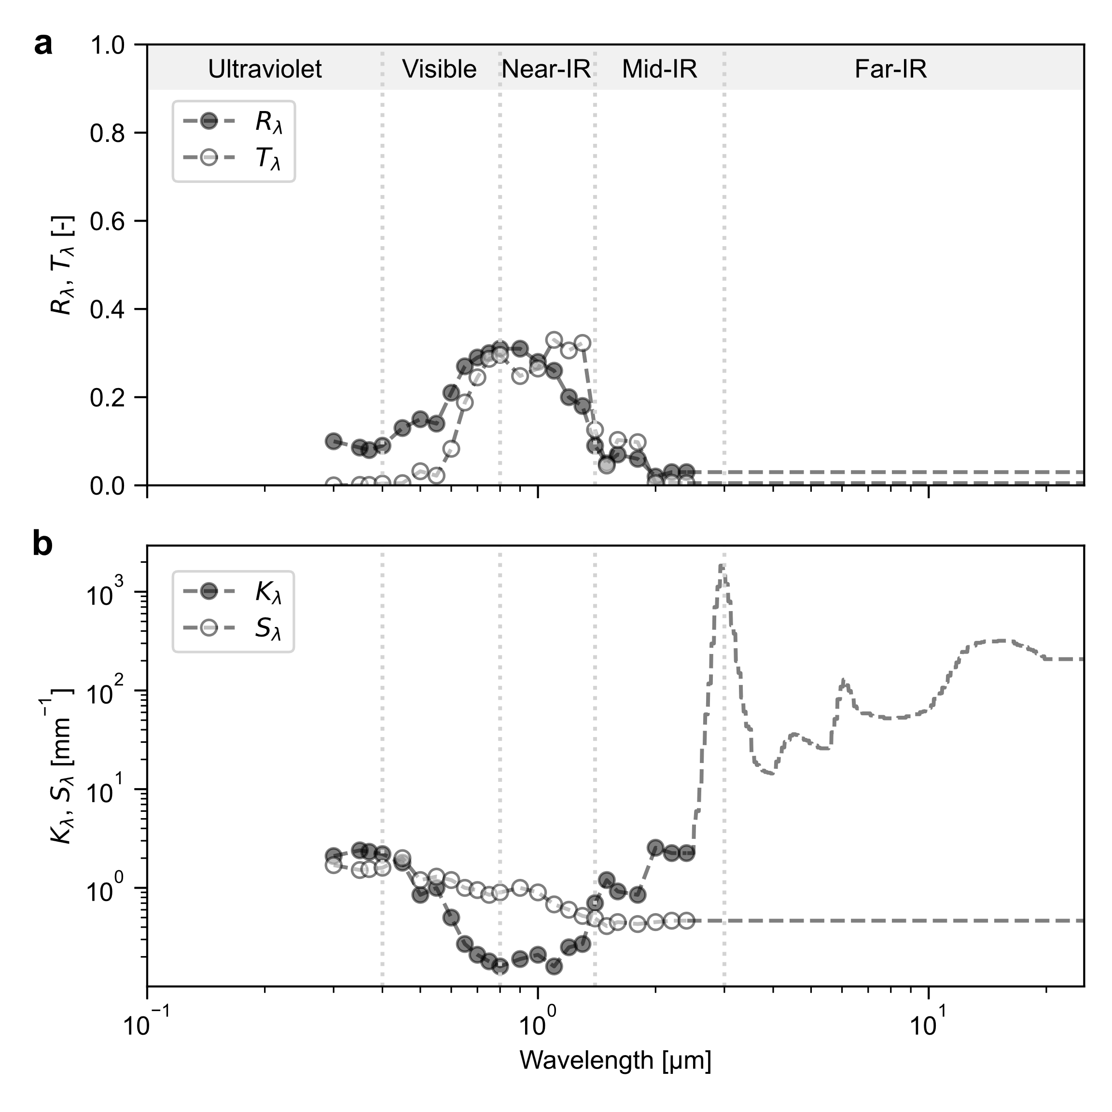

Fig. . Spectral radiative properties of the skin [13]: (a) Spectral reflectance (*Rλ*) and transmittance (*Tλ*) for living human skin with a thickness of 2.0 mm and (b) spectral absorption coefficient (*Kλ*) and spectral scattering coefficient (*Sλ*) of human skin. The markers represent measured data, and the dotted lines represent estimated data.

## Formularization of a prediction model for psychosensory intensity affected by radiation of different wavelengths

Fig. 8 illustrates a conceptual diagram of the proposed model, and Equations (3)–(6) are the formulae for the model. At its core, the model adapts a heat diffusion equation by incorporating a source term as shown in Equation (3). This addition is crucial for quantifying the impact of radiative heat flux across various wavelengths. This formulation enables us to compute the temperature evolution within the skin as a function of both position *x* and time *t*, with a particular focus on the radiative properties. A key aspect of our model is the calculation of heat flux by spectral irradiance *qir,λ*(*x*) at a specific wavelength *λ*, referring to principles from the Beer-Lambert law. As detailed in Equation (4), spectral irradianceis reflected at the surface (*x* = 0) by spectral reflectance *Rλ*, and then exponentially decays with depth into the skin *x*, modulated by the spectral absorption coefficient *Kλ* and scattering coefficient *Sλ*. This factor is added into the heat diffusion equation as a heat generation term due to irradiation. The model converts the temperature at warm receptor *T*wr(*t*) and its time derivative *dT*wr(*t*)/*dt* into the impulse frequency *I*(*t*) using Eq. (5). This equation is similar to the one by de Dear et al. [24] with minor modifications. To correctly represent the characteristics of warm receptor illustrated in Fig. 6, we defined a reference temperature at warm receptor *T*wr,ref. This reference temperature is a starting point where static discharge occurs and was set to 33.0 °C in this study. In other words, static discharge does not occur when the warm receptor temperature is below this threshold. The model differentiates based on the difference between the current temperature at the warm receptors *T*wr(*t*), and this reference temperature *T*wr,ref. If this difference is negative, meaning that the current temperature of warm receptor *T*wr (*t*) is lower than the reference temperature *T*wr,ref, the static discharge is set to zero. If the difference is positive, the response is represented by multiplying this difference *T*wr (*t*)−*T*wr,ref and the time derivative of warm receptor temperature *dT*wr(*t*)/*dt* by their respective coefficients (*C*s = 2 and *C*d = 56). These coefficients are the same as those used in de Dear’s model [24]. The proportionality constant for the static response *K*s is a straight-line approximation of the static characteristic curves shown in Fig. 6. Finally, the psychosensory intensity (PSI) is calculated by integrating the change in impulse frequency for 20 s using Eq. (6). This short cumulative evaluation quantitatively assesses the psychological response to radiation, similar to de Dear’s prediction of thermal sensation for step changes.

|  |  |  |
| --- | --- | --- |
|  |  | () |
|  |  | () |
|  |  | () |
|  |  | () |

In addition, we modified the method of setting a boundary condition to be able to perform simulations for each body part. The original model by de Dear et al. [24] predicts thermal sensation for the whole body, resulting from sudden ambient temperature changes; therefore, the core temperature *T*cr, which is one of the boundary conditions, was assumed to be the rectal temperature and was set at 36.9 °C. In general, the core temperature of the deep skin layer is considered equal to the peripheral arterial blood temperature flowing to that area, but it is not necessarily equal to the rectal temperature [25]. In particular, it has been reported [25] that the core temperature of bare hands is approximately 10 °C lower than the rectal temperature under 20 °C of room temperature. This is because peripheral arterial blood temperature decreases in cold conditions and the blood temperature in the extremities is lower than that in the trunk [25]. Therefore, the present model needs to set the core temperature *T*cr for each body part when a local body part is examined. In this study, we used a thermoregulation model JOS-3 [26] to calculate subject’s physiological state during the experiment. This model divides the human body into 17 parts and predicts thermal physiology of each body part. The local core temperature *T*cr calculated by JOS-3 model was used as one of the boundary conditions of the PSI model, as shown in Eq. (7). We used JOS-3 model in *pythermalcomfort*, a Python package to calculate thermal comfort indices (version 2.8.10) [27]. The heat exchange between the skin surface and the ambient environment occurs through three factors: convection with the ambient air, radiation with the surrounding surfaces, and spectral irradiance, as shown in Eq. (8) [28]. Convective heat transfer is calculated as a product of temperature difference between skin surface and the ambient air *T*sk−*T*a and its coefficient *h*c. Radiant heat transfer is calculated using Stefan–Boltzmann constant σ, emissivity of the skin surface in the long-wavelength range ε, skin temperature *T*sk, and mean radiant temperature *T*mrt.

|  |  |  |
| --- | --- | --- |
|  |  | () |
|  |  | () |



Fig. . Conceptual diagram of the proposed model: (a) Schematic diagram and (b) an example time-series of spectral irradiance, warm receptor temperature and impulse frequency after irradiation.

# Quantitative analysis of thermal perception affected by radiation of different wavelengths

To quantitatively analyze the experimental results on thermal sensation caused by radiation of different wavelengths, we reproduced our experiment and the previous experiments conducted by Narita et al. [1,2] and Matsui et al. [5] using the model proposed in this study. The model predicted the PSI for radiation in different wavelength ranges and the simulation results were compared with the experimental results.

## Nomoto’s experiment (this study)

### Experimental outline

See Chapter 2.

### Simulation conditions

First, human physiological simulation during the experiment was conducted using the thermoregulation model JOS-3 [26] to obtain the core temperature, which is the boundary condition of the PSI model. The input conditions for body composition were set as the average values of the male subjects (height: 1.73 m, weight: 64.9 kg, and age: 23 years) and female subjects (height: 1.59 m, weight: 49.7 kg, and age: 22 years). The physical activity ratio was set to 1.2 (sitting) [23], and the clothing insulation for each body part was set to the values measured with a thermal manikin (the clothing insulation for the whole body was 0.56 clo). The average hand core temperature for males and females was 35.5 °C, based on the calculations until a steady state was reached.

Next, the PSI due to radiation in each wavelength range was calculated using the model proposed in this study. Table 5 lists the simulation condition. Regarding the boundary conditions, the core temperature was set to 35.5 °C, as calculated by JOS-3 [26], and the ambient air temperature and mean radiant temperature were set to 25.3 °C and 25.0 °C, respectively, which are the average values measured in the climate chamber. The convective heat transfer coefficient was set to 4.5 W/(m2･K), referring to the value for a nude thermal manikin’s hand in still air [30]. The spectral properties of the skin were set to the data of Terada et al. [13]. The steady-state temperature was used as the initial temperature of each layer, and irradiation in the three wavelength ranges was applied for 20 s as an external stimulus to the skin surface. It should be noted that the spectral irradiation data are not the measured values, but the estimated values. The irradiance in each wavelength range was estimated based on Table 2. The radiant spectrum was estimated by combining data on the relative spectral irradiance of each radiation source and the spectral transmittance of the filters, which are shown in Fig. 3.

Table Simulation conditions for Nomoto’s experiment.

|  |  |  |  |  |
| --- | --- | --- | --- | --- |
|  |  | A (0.8–1.4 µm) | B (2.3–5.0 µm) | C (2.3 µm and above) |
| Convective heat transfer | [W/(m2･K)] | 4.5 | 4.5 | 4.5 |
| Boundary condition |  |  |  |  |
| * Core temperature | [°C] | 35.5 | 35.5 | 35.5 |
| * Air temperature | [°C] | 25.3 | 25.3 | 25.3 |
| * Mean radiant temperature | [°C] | 25.0 | 25.0 | 25.0 |
| Spectral skin properties |  | See Fig. 7 | See Fig. 7 | See Fig. 7 |
| Irradiation condition |  |  |  |  |
| * Irradiance | [W/m2] | See Table 2 | See Table 2 | See Table 2 |
| * Radiation spectrum | [-] | See Fig. 3 | See Fig. 3 | See Fig. 3 |

### Simulation results

Fig. 9 shows the simulation results. As shown in Fig. 9a, the temperature at warm receptor after 20 sec of irradiation was higher in the order of Radiation C (2.3 µm and above), Radiation B (2.3–5.0 µm), and Radiation A (0.8–1.4 µm). As shown in Fig. 9b, Radiation A (0.8–1.4 µm) was reflected higher at the skin surface and transmitted deeper into the skin than Radiation B and C. Thus, it stimulated the warm receptors located 0.5 mm below the skin surface to a lesser extent. In contrast, Radiation B (2.3–5.0 µm) and C (2.3 µm and above) provided high heating to the area near the warm receptors because most of the radiation was absorbed near the skin surface due to the spectral properties of the skin.

Therefore, as shown in Fig. 9c and Fig. 9d, the time series of the temperature at warm receptor and the impulse frequency increased in the order of Radiation A (0.8–1.4 µm), Radiation B (2.3–5.0 µm), and Radiation C (2.3 µm and above). The slight difference between the effects of Radiation B and C was due to the radiation intensity: the intensity of Radiation B was slightly lower than that of Radiation C.

Table 6 shows a comparison of the predicted PSI ratios and the thermal sensitivity ratios in each wavelength range. The predicted PSI values of Radiation A (0.8–1.4 µm), Radiation B (2.3–5.0 µm), and Radiation C (2.3 µm and above) were 32, 43 and 49, respectively. The result for each wavelength range is organized in terms of the ratio with the PSI of 1.00 for Radiation C. The PSI ratio for the radiation in each wavelength range is 0.65 (Radiation A): 0.88 (Radiation B): 1.00 (Radiation C). These results quantitatively corresponded to the experimental results, in which the thermal sensitivity ratio is 0.76 (Radiation A): 0.93 (Radiation B): 1.00 (Radiation C) as shown in Table 4.

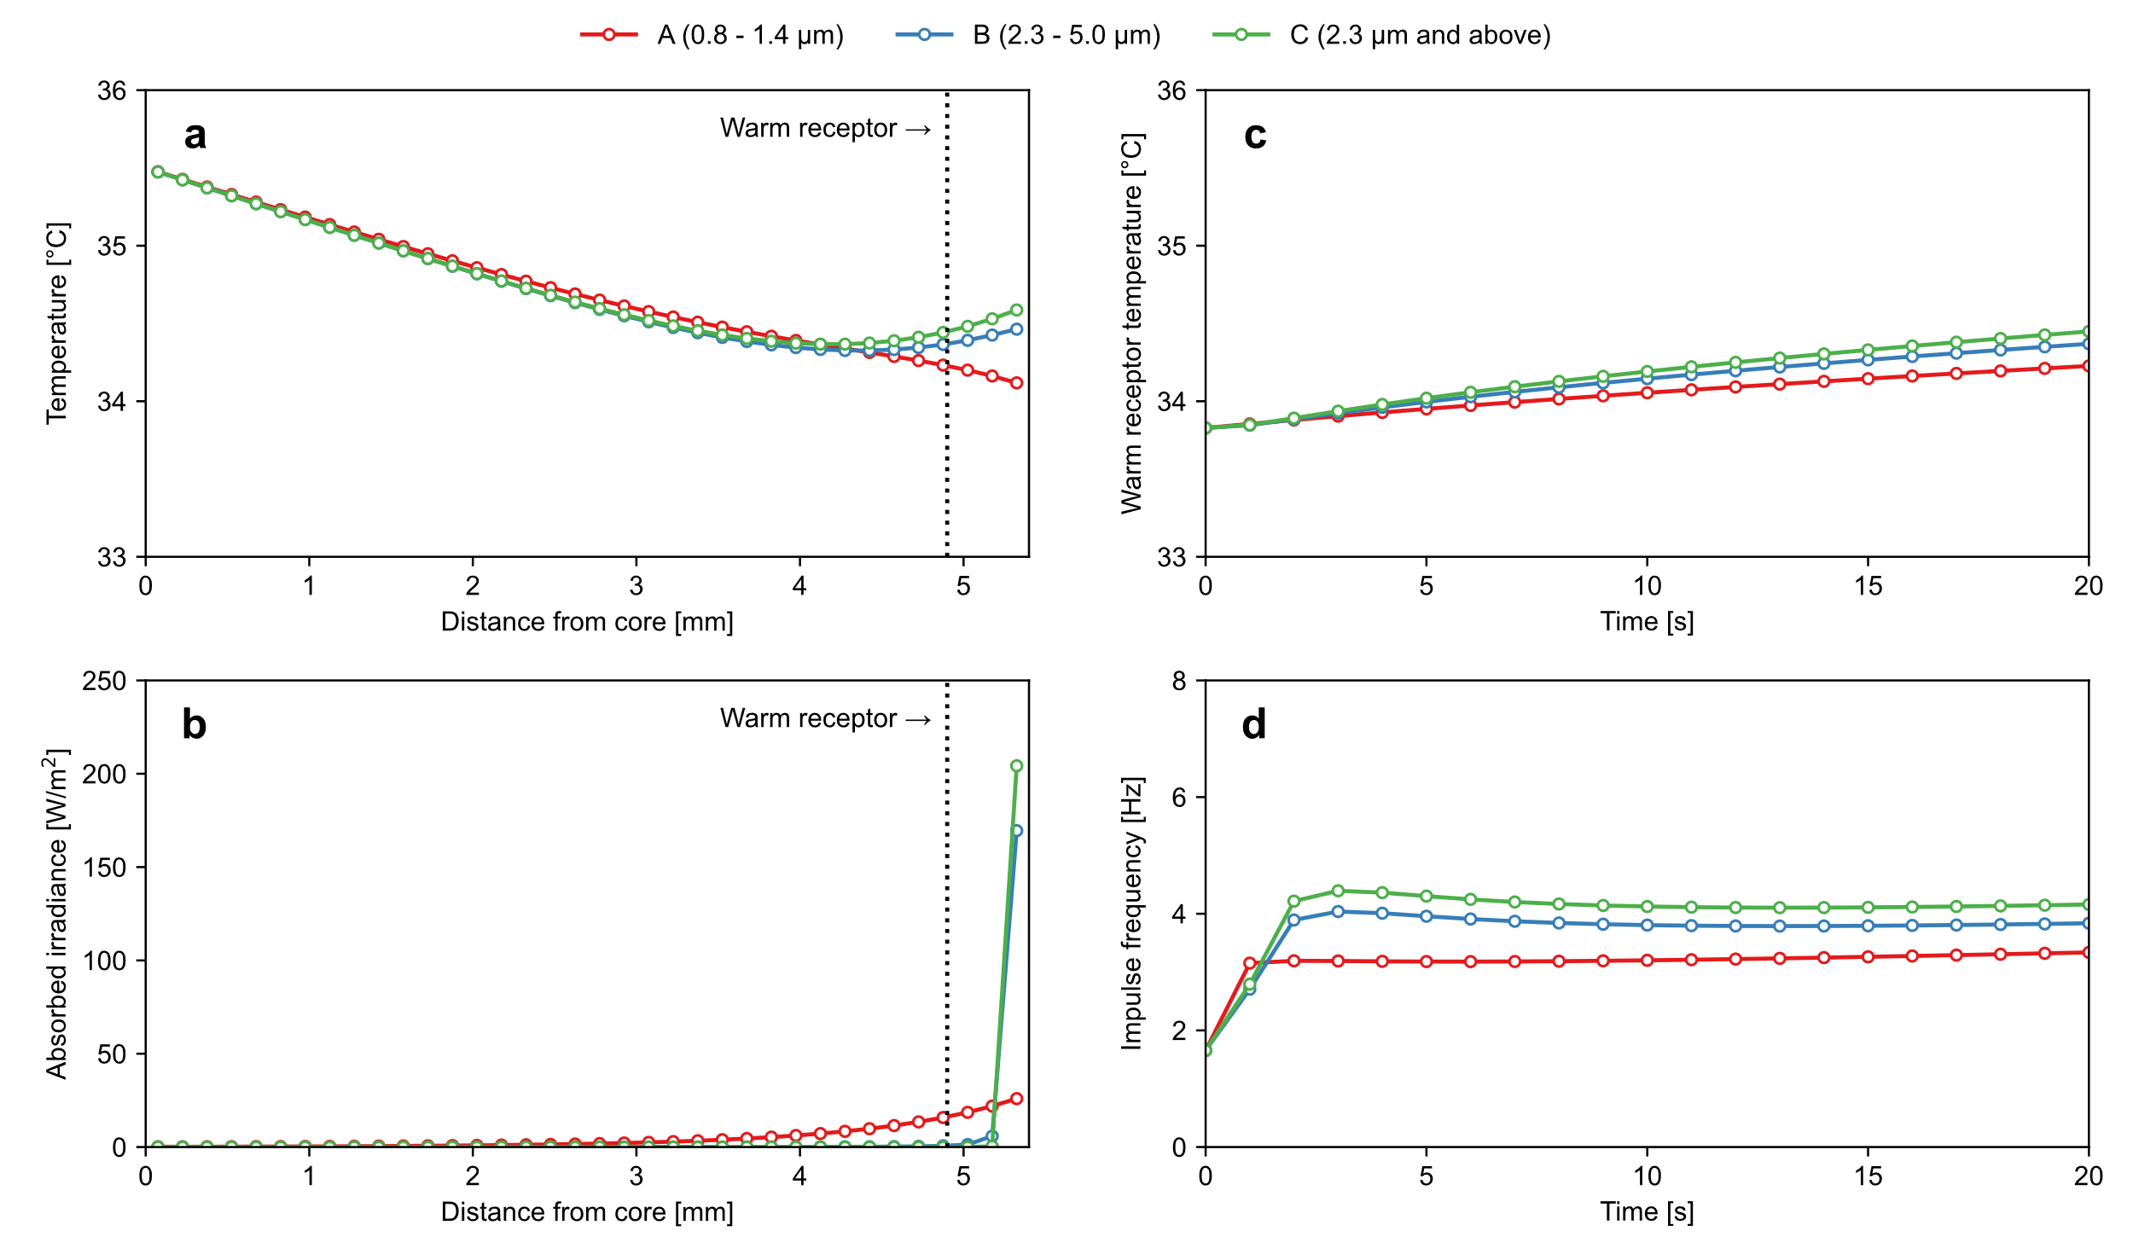

Fig. 9**.** Simulation results for Nomoto’s experiment: (a) Temperature distribution inside the skin; (b) absorbed irradiance distribution inside the skin; (c) time series of warm receptor temperature; (d) time series of impulse frequency.

Table Comparison of predicted PSI ratios and thermal sensitivity ratios in each wavelength range for Nomoto’s experiment.

|  |  |  |  |
| --- | --- | --- | --- |
|  | A (0.8–1.4 µm) | B (2.3–5.0 µm) | C (2.3 µm and above) |
| PSI | 32 | 43 | 49 |
| PSI ratio [-] | 0.65 | 0.88 | 1.00 |
| Thermal sensitivity ratio [-] (N=20) | 0.76 | 0.93 | 1.00 |

## Narita’s experiment

### Experimental outline

Narita et al. [1,2] conducted an experiment to determine the range of solar radiation wavelength that had the greatest effect on thermal sensation. They conducted a paired comparison experiment in which the backs of a subject’s hands were irradiated with a combination of two out of three different types of radiation: visible (0.30–0.84 μm), near-infrared (0.80–1.35 μm), and mid-infrared (1.70–2.30 μm). The experiment was conducted in a climate chamber with a neutral thermal environment; the air temperature, relative humidity, mean radiant temperature, and air velocity were 24.7 °C, 67%, 25.5 °C, and 0.1 m/s, respectively. The subjects wore clothes with insulation of approximately 0.5 clo and were instructed to sit quietly.

The irradiation conditions are shown in Fig. 10. The radiation intensity was measured with a blackbody radiation thermometer just before irradiating the subjects; the radiation intensity of the three wavelength ranges was approximately 1220 W/m2.

From the experimental results, it was found that mid-infrared radiation produced warmer thermal sensations on the skin than visible and near-infrared radiation, even at the same irradiation intensity. Furthermore, they quantified the sensitivity to the radiation in each wavelength range by adjusting the radiation intensity. The thermal sensitivity ratio was 1.43: 1.00: 1.67 for the visible (0.30–0.84 μm), near-infrared (0.80–1.35 μm), and mid-infrared (1.70–2.30 μm) radiation.

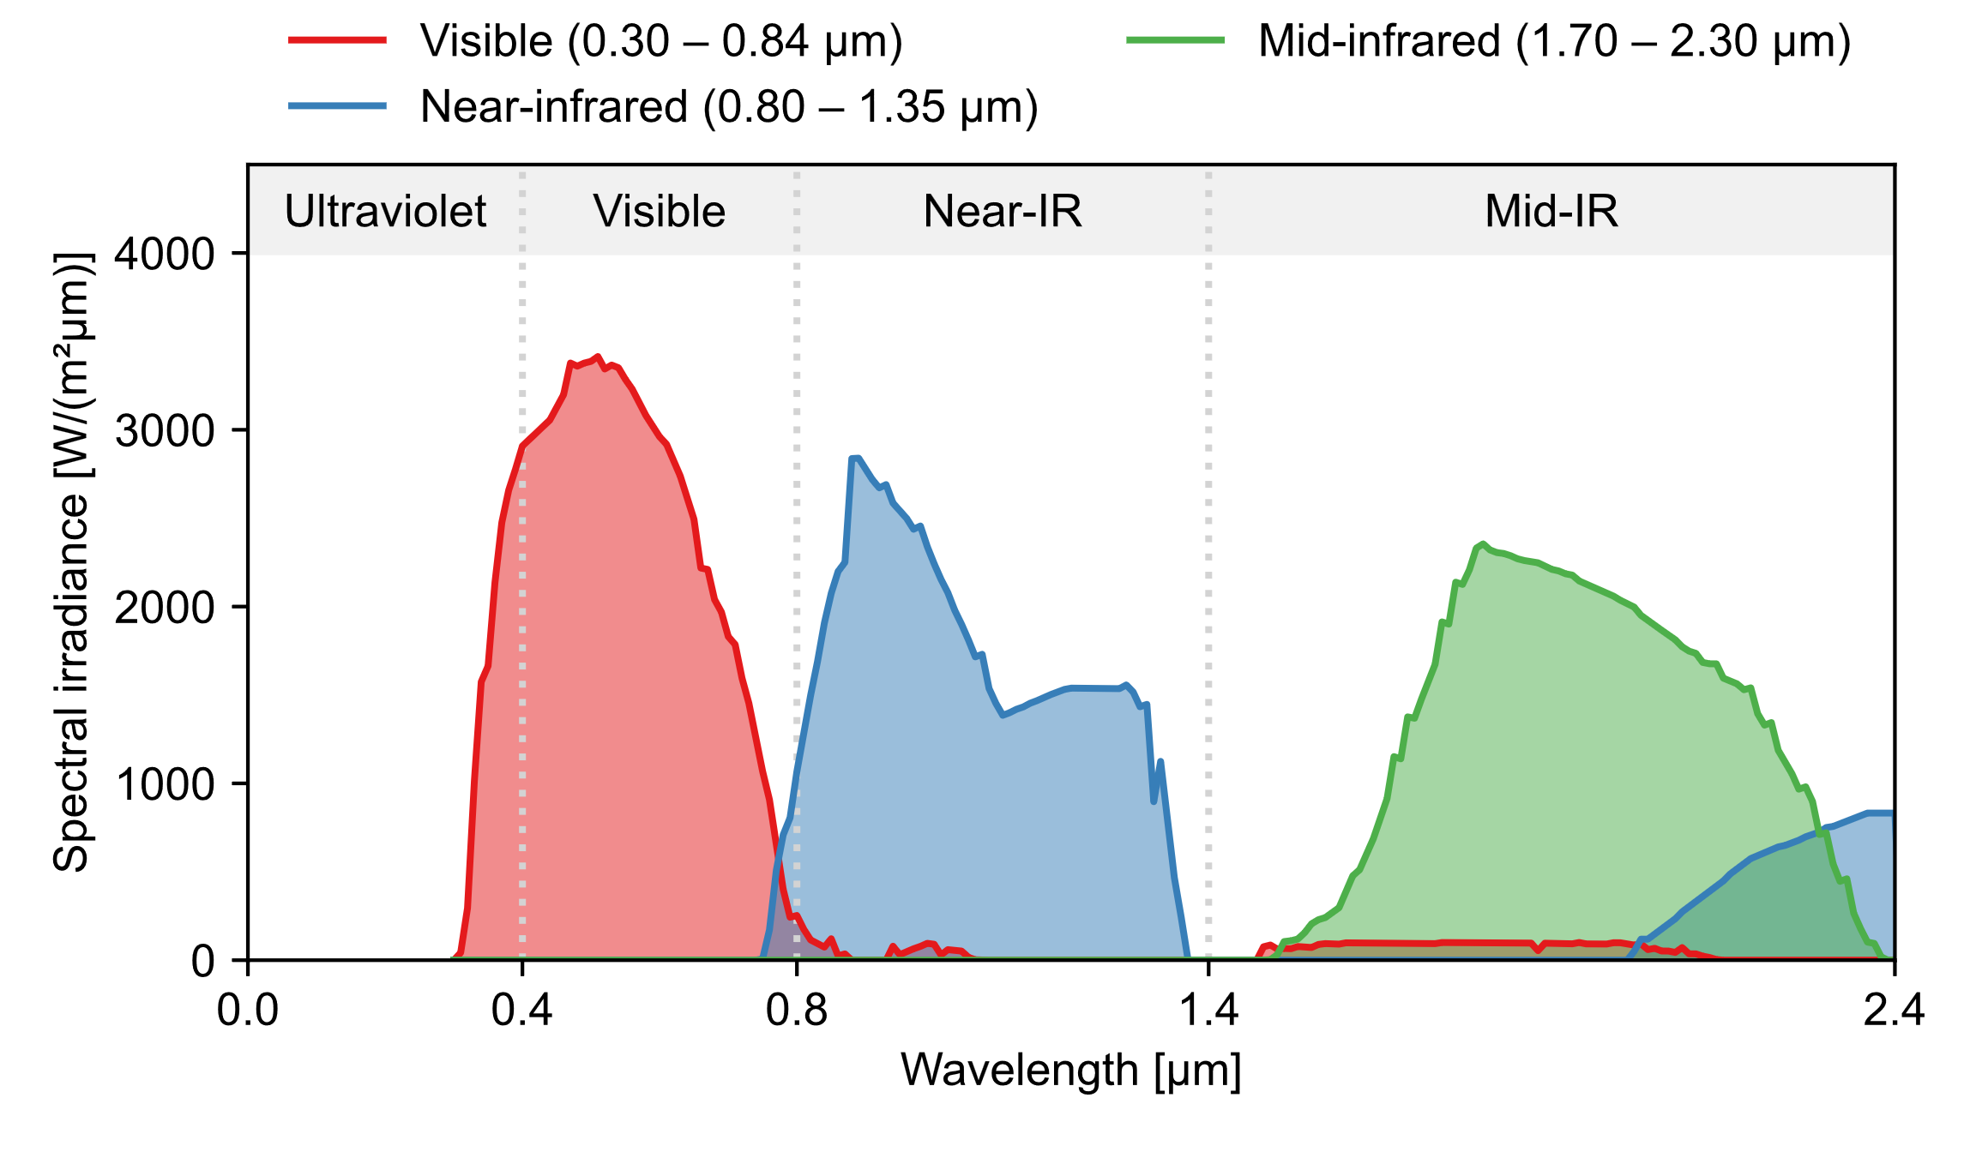

Fig. Irradiation conditions for Narita’s experiment [2]: The data are the spectral radiation from the artificial solar lamps through the optical filters.

### Simulation conditions

First, human physiological simulation during the experiment was conducted using the thermoregulation model JOS-3 [26] to obtain the core temperature. The input conditions of body composition were set as the average values of 30 male subjects (height: 1.71 m, weight: 63.2 kg, age: 23 years) and 33 female subjects (height: 1.59 m, weight: 49.7 kg, age: 22 years). The physical activity ratio was set to 1.2 (sitting) [29] and the clothing insulation for each body part was set based on our previous study (data on ensemble F) [31]. From the calculations, the average core temperature of the hand for males and females was 35.9 °C until a steady state was reached.

Next, the PSI due to radiation in each wavelength range was calculated using the model proposed in this study. Table 7 lists the simulation conditions. The boundary conditions were set as follows: the core temperature was set to 35.9 °C, as calculated by JOS-3 [26], and the ambient air temperature and mean radiant temperature were set to 24.7 °C and 25.5 °C, respectively, which were the average measured values. The convective heat transfer coefficient was set to 6.4 W/(m2･K), as calculated from the measurements in Narita’s experiment [1,2]. The spectral properties of the skin were obtained from the data of Terada et al. [13]. The steady-state temperature was used as the initial temperature of each layer, and the spectral irradiance of 1220 W/m2 in the three wavelength ranges was applied for 20 s as an external stimulus to the skin surface.

Table Simulation conditions for Narita’s experiment [1,2].

|  |  |  |
| --- | --- | --- |
| Convective heat transfer coefficient | [W/(m2･K)] | 6.4 |
| Boundary conditions |  |  |
| * Core temperature | [°C] | 35.9 |
| * Air temperature | [°C] | 24.7 |
| * Mean radiant temperature | [°C] | 25.5 |
| Spectral skin properties |  | See Fig. 7 |
| Irradiation condition |  |  |
| * Irradiance | [W/m2] | 1220 |
| * Spectral irradiance | [W/(m2･µm)] | See Fig. 10 |

### Simulation results

Fig. 11 shows the simulation results. As shown in Fig. 11a, the temperature at warm receptor after 20 sec of irradiation was higher in the order of mid-infrared (1.70–2.30 μm), visible (0.30–0.84 μm), and near-infrared (0.80–1.35 μm) radiation. In Fig. 11b, the near-infrared radiation (0.80–1.35 μm) is reflected at the skin surface and penetrates deeper into the skin than radiation in the other wavelength ranges. In contrast, visible (0.30–0.84 μm) and mid-infrared (1.70–2.30 μm) radiation have a high heating effect near the warm receptors because most of the radiation is absorbed near the skin surface due to the spectral properties of the skin. Therefore, as shown in Fig. 11c and Fig. 11d, the time series of the temperature at the warm receptor and the impulse frequency increase in the order of near-infrared (0.80–1.35 μm), visible (0.30–0.84 μm), and mid-infrared (1.70–2.30 μm) radiation. This is qualitatively consistent with the results of the thermal sensation votes in the experiment [1,2].

Table 8 shows a comparison of the predicted PSI ratios and thermal sensitivity ratios in each wavelength range. The predicted PSI values of visible (0.30–0.84 μm), near-infrared radiation (0.80–1.35 μm), and mid-infrared (1.70–2.30 μm) were 224, 180, and 258, respectively. The results in each wavelength range are organized in terms of the ratio of the near-infrared radiation, which is equal to 1.00. The PSI ratio for the radiation in each wavelength range is 1.24 (near-infrared): 1.00 (visible): 1.43 (mid-infrared). This result corresponds quantitatively to the experimental result [1,2], in which the thermal sensitivity ratio is 1.43 (near-infrared): 1.00 (visible): 1.67 (mid-infrared).

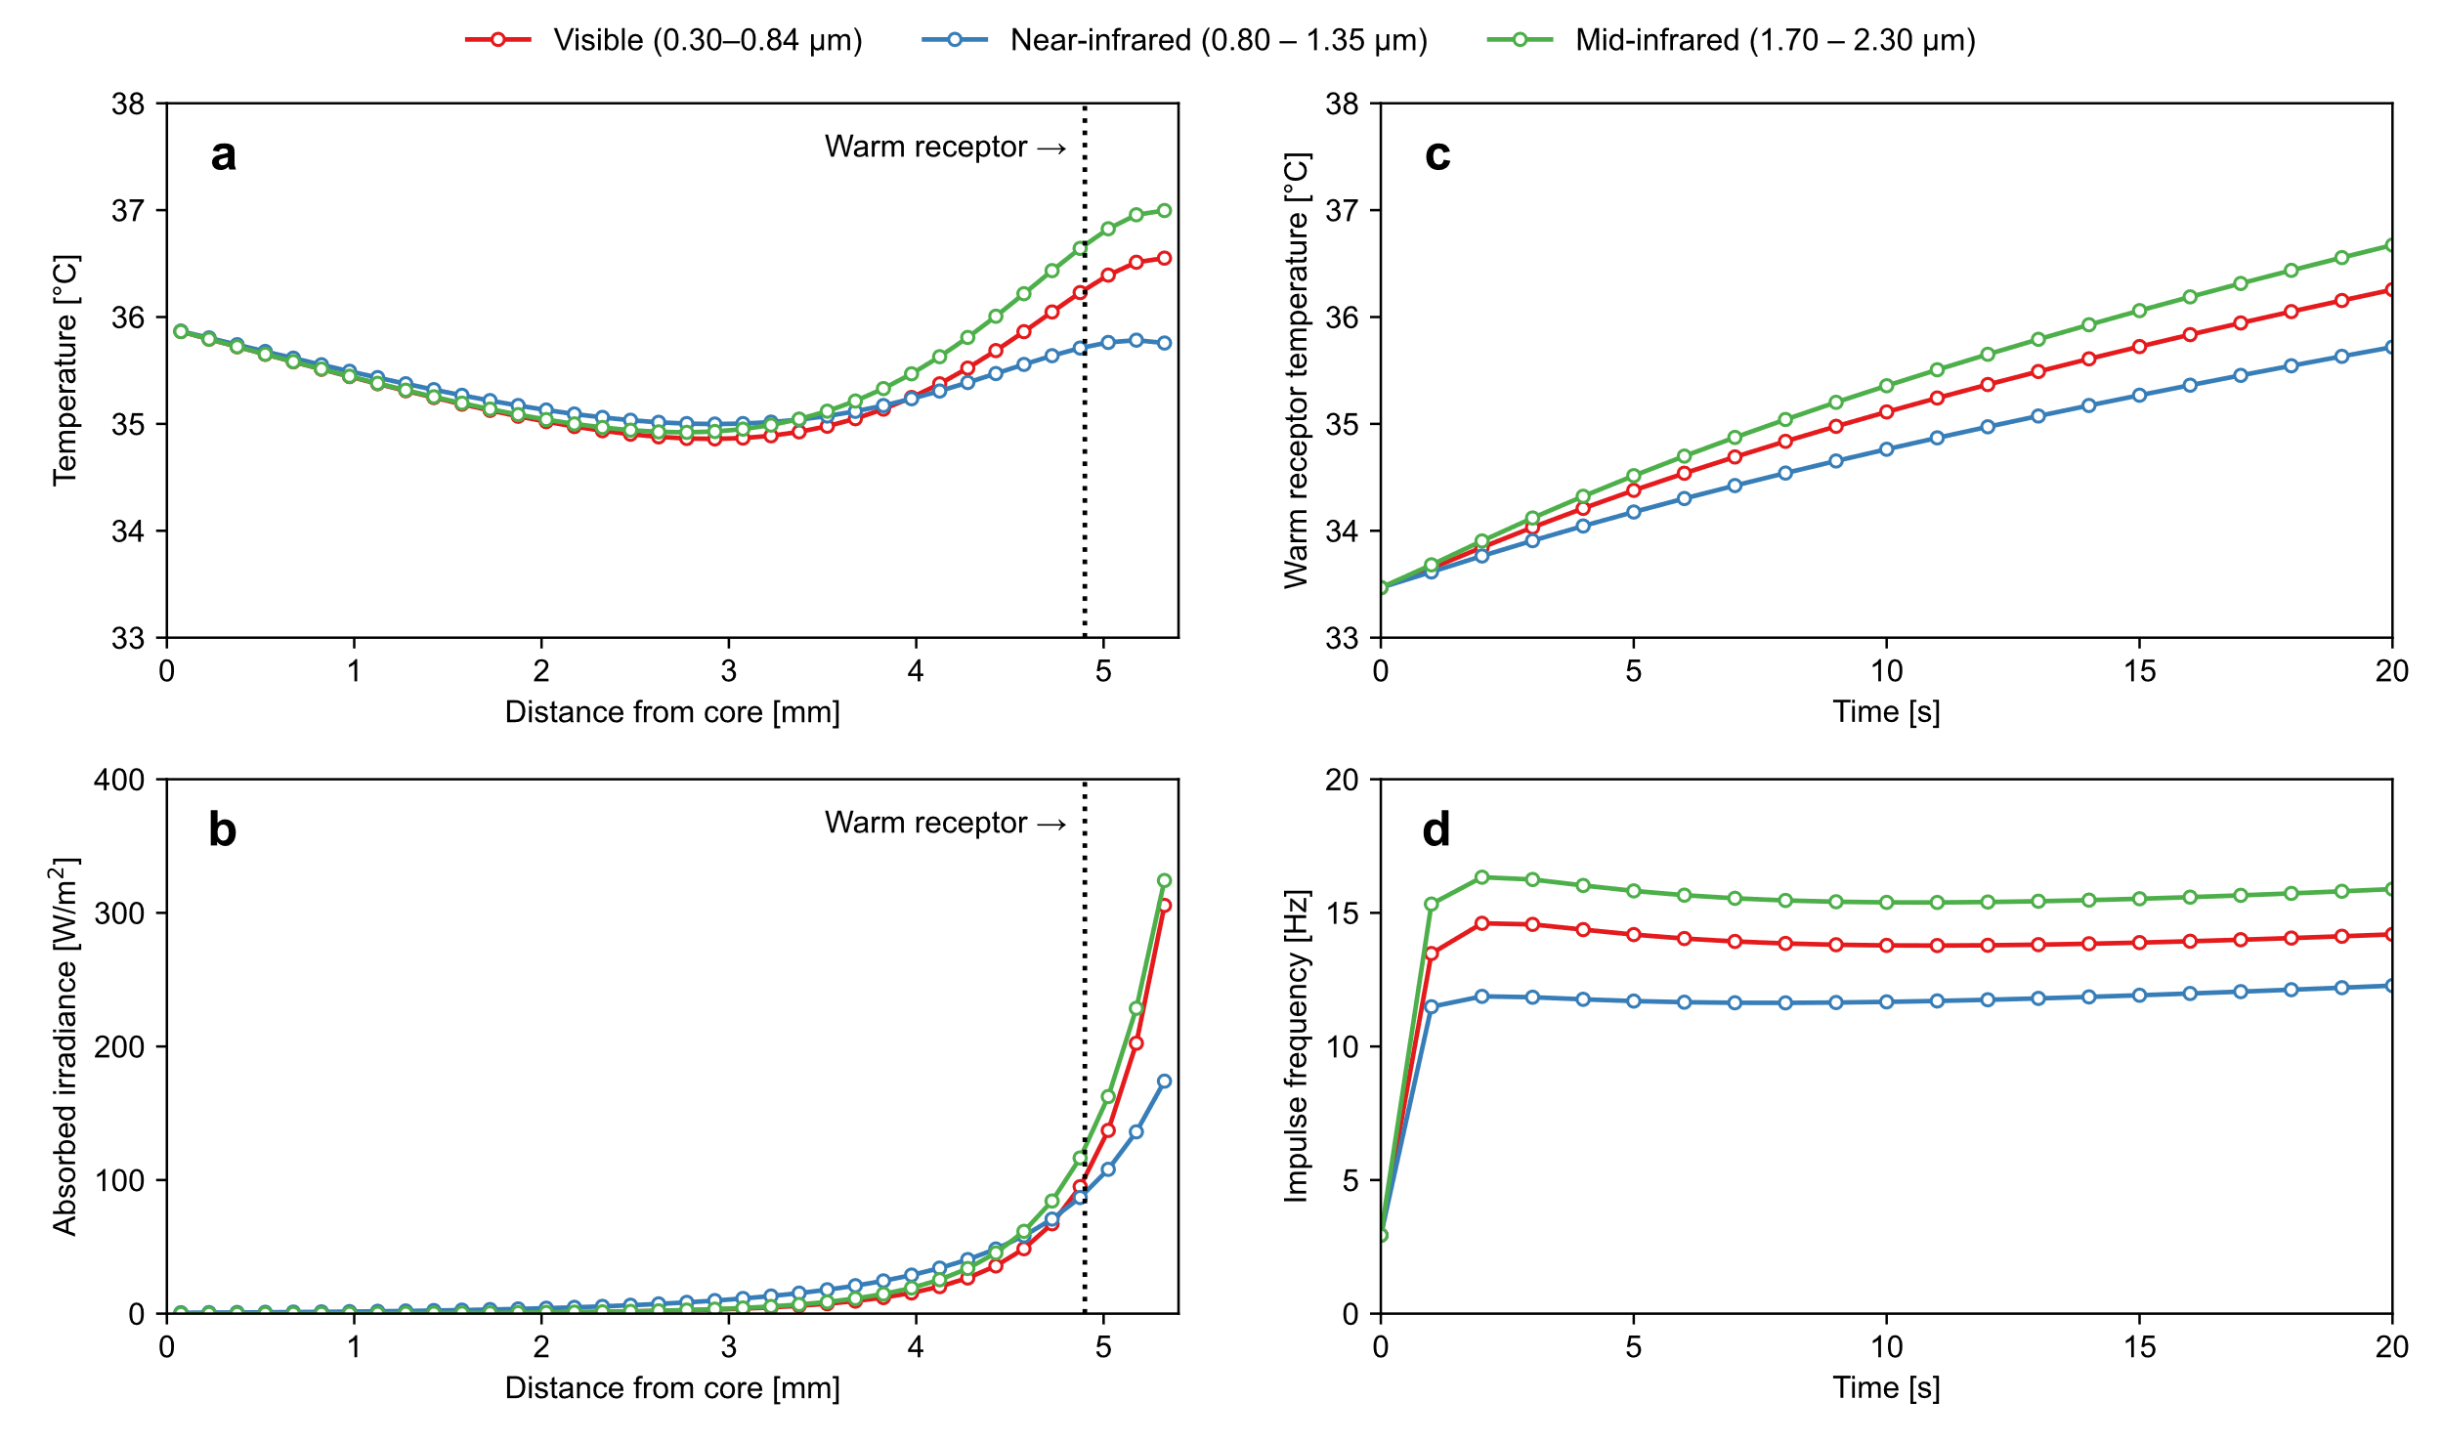

Fig. . Simulation results for Narita’s experiment [1,2]: (a) temperature distribution inside the skin; (b) absorbed irradiance distribution inside the skin; (c) time series of warm receptor temperature; (d) time series of impulse frequency.

Table Comparison of predicted PSI ratios and thermal sensitivity ratios in each wavelength range for Narita’s experiment [1,2].

|  |  |  |  |
| --- | --- | --- | --- |
|  | Visible  (0.80–1.35 μm) | Near-infrared  (0.80–1.35 μm) | Mid-infrared  (1.70–2.30 μm) |
| PSI | 224 | 180 | 258 |
| PSI ratio | 1.24 | 1.00 | 1.43 |
| Thermal sensitivity ratio [1,2] | 1.43 | 1.00 | 1.67 |

## Matsui’s experiment

### Experimental outline

Matsui et al. [5] conducted an experiment with 155 subjects, excluding infants and elderly people, to investigate thermal sensation on the cheek and hands irradiated with infrared radiation at three different wavelengths: near- to mid-infrared radiation (0.72–2.7 μm), mid- to far-infrared radiation (1.5–4.8 μm), and far-infrared radiation (6.0–20.0 μm).

Fig. 12 shows the irradiation conditions. Similar to our experiment and Narita’s experiment [1,2], three types of spectral irradiance were created by infrared radiant sources with filters that have high transmittance in the target wavelength ranges. The power supply voltage was adjusted to provide 2000 W/m2 of irradiance to the subjects. The irradiation duration was 20 s for the back of the hand and 15 s for the cheek, and the subjects reported their thermal sensation in the irradiated areas after the experiments. The air temperature in the room was maintained in the range of 17–22 °C during the experiment.

The experimental results showed that mid- to far-infrared radiation (1.5–4.8 μm) and far-infrared radiation (6.0–20.0 μm) caused a warmer thermal sensation on the skin than near- to mid-infrared radiation (0.72–2.7 μm), even at the same irradiation intensity. In addition, it was found that longer wavelengths (> 2 μm) caused warmer thermal sensations on the skin than shorter wavelengths (< 2 μm). There were no significant differences in the results between the groups, such as those related to sex or age.

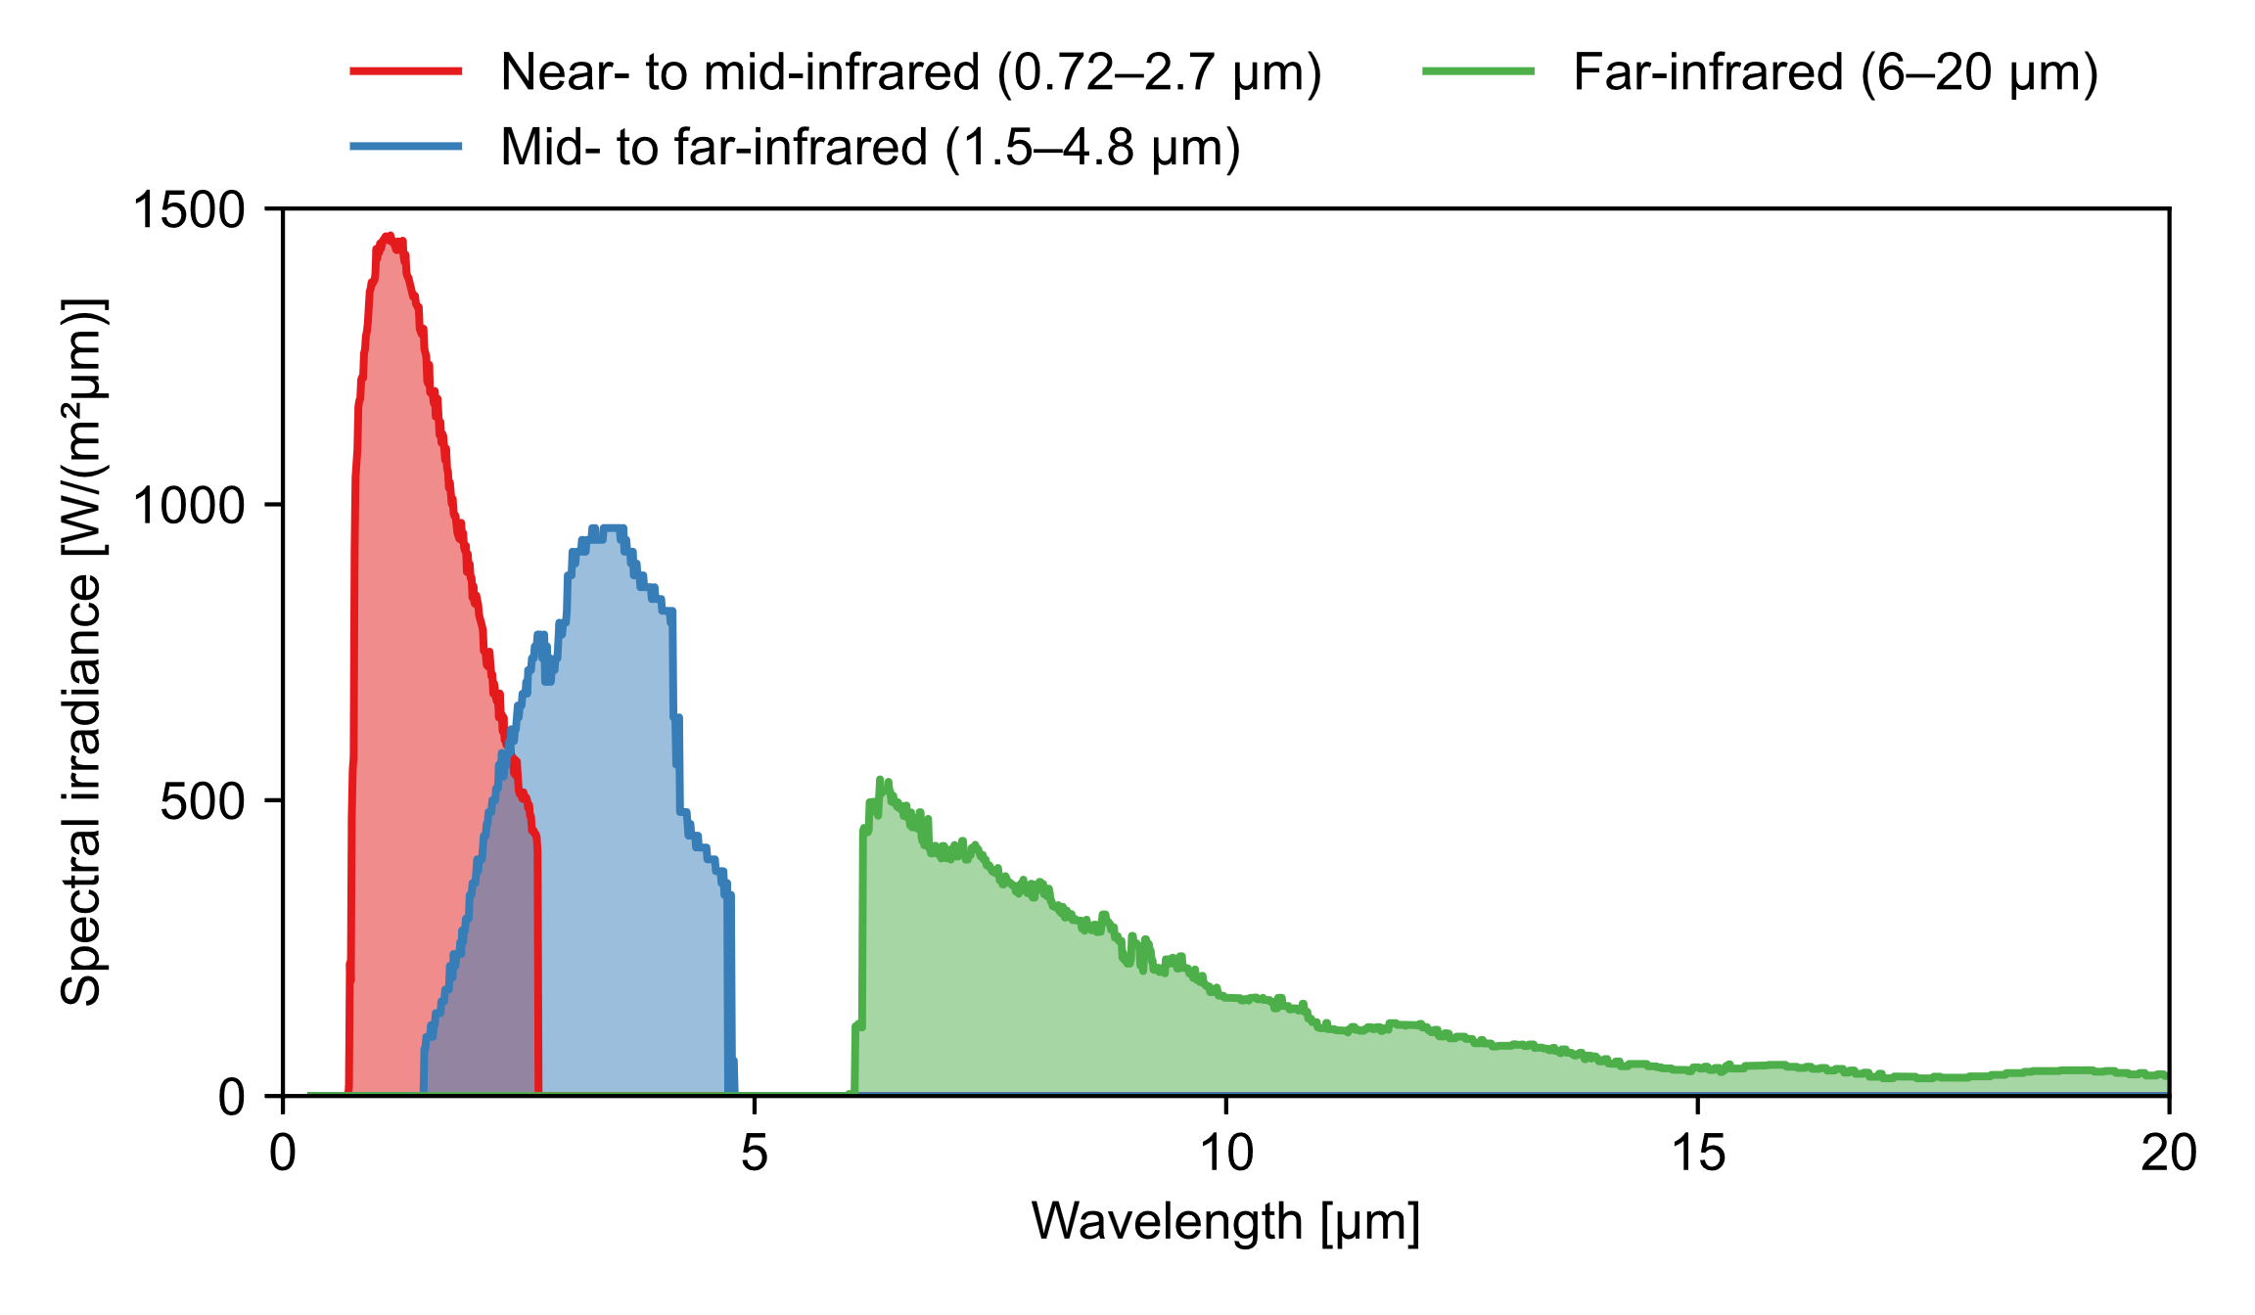

Fig. . Irradiation conditions for Matsui’s experiment [5]: This figure is created from the data on the relative spectral irradiance of each type of radiation and the spectral transmittance of filters.

### Simulation conditions

Human physiological simulation during the experiment was conducted using the thermoregulation model JOS-3 [26] to obtain the core temperature. Because the paper by Matsui et al. [5] does not provide the detailed information to perform the human physiological simulation, we set the same anthropometric, clothing, and physical activity data as that used by Narita et al. [1,2] and set the thermal environment data described in the paper by Matsui to JOS-3 model [26]. The core temperature of the hand was 32.5 °C when a steady state was reached.

The PSI due to radiation in each wavelength range was calculated using the PSI model. Table 9 lists the simulation conditions. The ambient air temperature was set to 19.5 °C, which is the median value of the operative temperature in the room. We set the convective heat transfer coefficient to 4.5 W/(m2･K), which is the value for the sitting nude thermal manikin’s hand in still air, as presented in previous studies [30]. The data presented by Terada et al. [13] were used for the spectral properties of the skin in the wavelength range of 0.3–2.4 μm. For wavelengths above 2.4 μm, the spectral reflectance at the skin surface and spectral scattering coefficient inside the skin were set to corresponding values at 2.4 μm. The water data were used as the skin spectral absorption coefficients for wavelengths above 2.4 μm, as they agree with the skin spectral properties with extremely high accuracy and are therefore suitable for substitution [13]. The steady-state temperature was used as the initial temperature of each layer, and irradiation of 2000 W/m2 in the three ranges of wavelength was applied for 20 s as an external stimulus to the skin surface. It was assumed that the irradiation of 2000 W/m2 in the experiment included the radiation from the ambient environment, i.e., the radiosity from the ambient environment to the skin was set to 0 W/m2.

Table Simulation conditions for Matsui’s experiment [5].

|  |  |  |
| --- | --- | --- |
| Convective heat transfer coefficient | [W/(m2･K)] | 4.5 |
| Boundary conditions |  |  |
| * Core temperature | [°C] | 32.5 |
| * Air temperature | [°C] | 19.5 |
| Spectral skin properties |  | See Fig. 7 |
| Irradiation condition |  |  |
| * Irradiance | [W/m2] | 2000 |
| * Spectral irradiance | [W/(m2･µm)] | See Fig. 12 |

### Simulation results

Fig. 13 shows the simulation results. As shown in Fig. 13a and Fig. 13b, near- to mid-infrared radiation (0.72–2.7 μm) is reflected more at the skin surface and is transmitted deeper into the skin than the radiation in other ranges of wavelength, so it stimulates the warm receptors located 0.5 mm below the skin surface to a lesser extent. In contrast, mid- to far-infrared radiation (1.5–4.8 μm) and far-infrared radiation (6.0–20.0 μm) have a high heating effect near the warm receptors because most of the radiation is absorbed near the skin surface due to the skin spectral properties. Therefore, as shown in Fig. 13c and Fig. 13d, the time series of the warm receptor temperature and the impulse frequency increase in the order of near- to mid-infrared radiation (0.72–2.7 μm), mid- to far-infrared radiation (1.5–4.8 μm), and far-infrared radiation (6.0–20.0 μm). The slight difference between mid- to far-infrared radiation (1.5–4.8 μm) and far-infrared radiation (6.0–20.0 μm) is due to the spectral properties of the skin: mid- to far-infrared radiation (1.5–4.8 μm) is slightly reflected at the wavelength of approximately 2 μm, whereas far-infrared radiation (6.0–20.0 μm) is almost entirely absorbed near the skin surface.

Table 10 lists the predicted PSI values and their ratios in each wavelength range. The result in each wavelength range is organized in terms of the PSI ratio irradiated with far-infrared radiation (6.0–20.0 μm), which equals 1.00. The PSI ratio for the radiation in each wavelength range is 0.70 (near- to mid-infrared [0.72–2.7 μm]): 0.99 (mid- to far-infrared [1.5–4.8 μm]): 1.00 (far-infrared [6.0–20.0 μm]). These results quantitatively correspond to the experimental results [5]: mid-infrared and far-infrared radiation at wavelengths above 2 μm cause a warmer thermal sensation on the skin than near-infrared radiation at wavelengths below 2 μm, although there is no significant difference in thermal sensation caused by mid-infrared and far-infrared radiation at wavelengths above 2 μm.

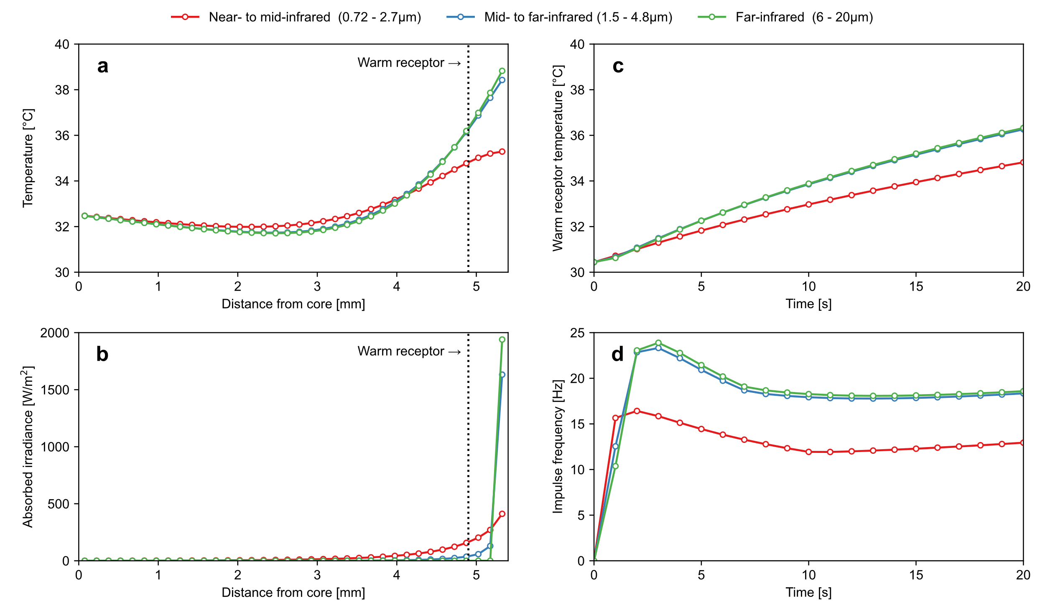

Fig. . Simulation results for Matsui’s experiment [5]: (a) temperature distribution inside the skin; (b) absorbed irradiance distribution inside the skin; (c) time series of warm receptor temperature; (d) time series of impulse frequency.

Table Predicted PSI values and their ratios in each wavelength range for Matsui’s experiment [5].

|  |  |  |  |
| --- | --- | --- | --- |
|  | Near- to mid-infrared  (0.72–2.7 μm) | Mid- to far-infrared  (1.5–4.8 μm) | Far-infrared  (6.0–20.0 μm) |
| PSI | 266 | 375 | 379 |
| PSI ratio | 0.70 | 0.99 | 1.00 |

## Relationship between simulated thermoreceptor activity and thermal sensation votes

Fig. 14 shows the relationship between the simulated PSI differences and the relative thermal sensation votes in three types of paired comparison experiments. In these experiments, the subjects were asked to vote on the irradiated area that felt hotter when the backs of their hands were irradiated with radiation of two different wavelength ranges. This relative thermal sensation was assumed proportional to the *ΔPSI* ratio, which is the difference between the ratios of PSI due to radiation in each wavelength range. The results of the thermal sensation votes in the three human subject experiments shown above correspond to the PSI calculated by the model. The coefficient of determination of the regression line was 0.53 (n=9), and the simulated PSI differences generally corresponded with the results of the mean thermal sensation votes obtained in the three human subject experiments. This graph can be used to interpret the subjective relative thermal sensation vote from the PSI calculated by the model, but it should be noted that the scale interval of the relative thermal sensation is assumed to be equal.

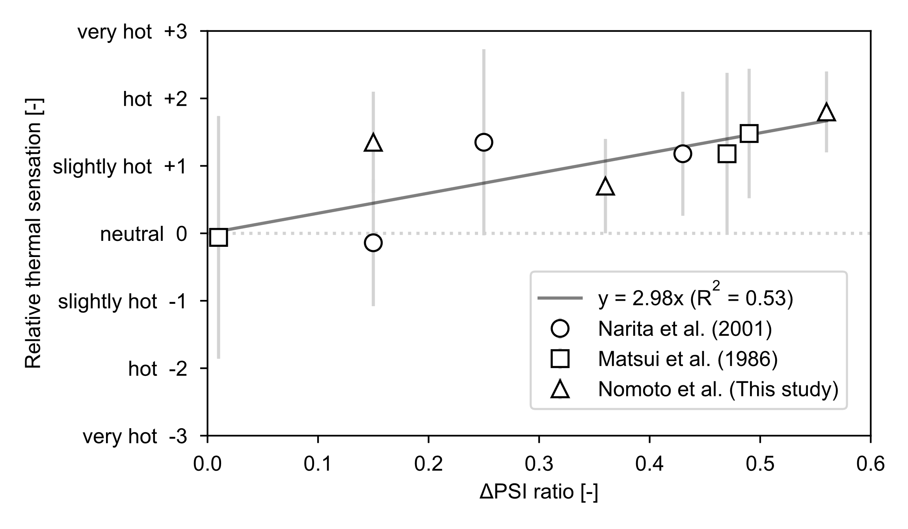

Fig. 14**.** Relationship between simulated PSI differences and relative thermal sensation votes in three types of paired comparison experiments: The plots show the mean values of the relative thermal sensation votes from the experiments, with standard deviations represented as bars.

# Standardization of psychosensory intensity of the skin irradiated with radiation of different wavelengths

Fig. 15 shows the PSI ratios of radiation at different wavelengths. The PSI was calculated at every 0.1 μm interval in the range of 0.3–20.0 μm, and the results were normalized with the maximum PSI value set to 1.0. The calculation conditions were identical to those used in our experiment. Since the results are presented as ratios, they are not affected by boundary conditions such as core temperature and ambient temperature. The maximum PSI was observed with radiation at 2.5 μm; above 2.5 μm, the PSI ratio remained relatively constant. The PSI ratio for the radiation at 1.0 μm was the lowest, whereas that for the radiation in the range of 0.6–1.2 μm was less than 60% of the value for far-infrared radiation. This is attributed to the fact that the warm receptors beneath the skin surface are hardly stimulated by the radiation at approximately 1.0 μm due to the high spectral reflectance and transmittance of the skin. These results are qualitatively consistent with those of previous studies [2,5,7]. Additionally, within the visible range, it is clear that shorter wavelength colors like violet (around 0.4 μm) and blue (around 0.5 μm) give a warmer sensation than longer wavelength colors such as red (around 0.6–0.8 μm).

These findings can be useful for developing materials that selectively reflect and absorb radiation in specific wavelength ranges, or heaters that provide efficient heating with low energy consumption. For example, this graph indicates infrared cut glass, which transmits visible rays while selectively blocking infrared and ultraviolet rays, effectively reduces thermal discomfort caused by direct solar radiation transmitted through the glass. Moreover, glass should transmit some visible light for visibility purposes, but if it can selectively transmit longer wavelengths (such as red light) and block shorter wavelengths (such as blue light), it can further reduce thermal discomfort. Additionally, the data indicate that far-infrared heaters are more energy-efficient in heating the human body compared to bonfire or halogen heaters, which contain near-infrared radiation.

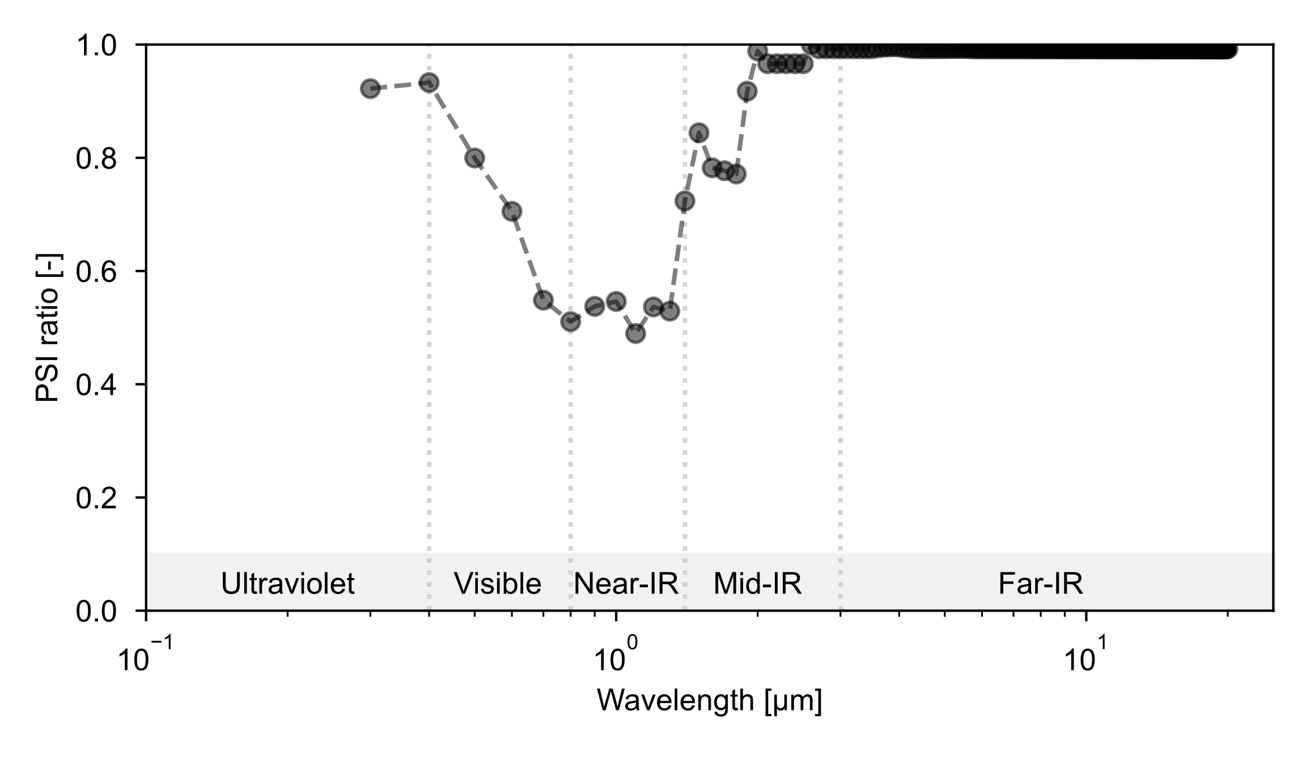

Fig. 15**.** PSI ratios for radiation of different wavelengths (every 0.1 μm interval).

# Discussion

## Characteristics of far-infrared radiation

Fig. 9b and Fig. 13b demonstrate that far-infrared radiation exhibits minimal reflection at the skin surface, with the majority of its energy being absorbed at a depth of approximately 0.2 millimeters from the surface. In Japan, there has long been a belief that *far-infrared radiation efficiently heats deep into the body*. However, our findings reveal that far-infrared radiation does not have the property of penetrating deep into the body; instead, its warming effect is primarily due to the stimulation of thermoreceptors located just beneath the skin surface. Therefore, the traditional belief is probably less about the penetrating nature of far-infrared radiation and more about its effective heating to warm receptors. If we are considering deep tissue heating, it is more comprehensible to think of the absorbed far-infrared radiation spreading deeply within the body through the circulatory system.

## Applicability and limitations of the model

### Skin color

The model developed in this study uses the skin spectral data provided by Terada et al. [13], which are based on Japanese subjects. Because the subjects in the experiments reproduced in this study are Japanese, the model can be applied to them. However, skin spectral properties vary with skin color, so it is advisable to modify the skin spectral data when evaluating the effect of thermal sensation caused by radiation in different wavelength ranges for subjects with white or black skin. As shown in previous studies [14–17], the reflectance of the skin of White and Black individuals differs significantly in the visible to near-infrared range. Thus, the thermal sensation caused by solar radiation is considered to differ greatly depending on the skin color. In contrast, in the far-infrared range, the spectral properties of the skin of the two groups are almost identical, suggesting minimal differences in thermal sensation from far-infrared radiation.

### Long-term irradiation

Because the irradiation time of the experiments reproduced in this study was 20 s, the experiment was considered to have ended before the human thermoregulation was fully activated. Thus, the model does not consider human thermoregulation such as vasoconstriction, vasodilation, sweating, and shivering. According to the study by Lipkin et al. [32], the skin thermal diffusivity is determined as a single value for short-duration heating of the skin (less than 20 s), and the PSI model uses this value as well as that proposed by de Dear et al. [24]. Because the irradiation time in the experiments reproduced in this study was short (less than 20 s), this model can be applied even though it does not have human thermoregulation functions. However, our body has a mechanism to regulate body temperature according to our thermal state, and as the body temperature rises, the blood flow and sweating rate increase. Therefore, in the future, it is desirable to combine the model with a thermoregulation model to evaluate the PSI over extended periods.

### Irradiated area

In this study, we replicated experiments where the backs of the subject's hands were irradiated with radiation in different wavelength ranges. However, further study is needed to apply the model to the whole body or other body parts. Many researchers such as Stevens et al. [33] and Luo et al. [34] have reported that human thermal sensitivity varies by body part. The forehead and cheeks are significantly more sensitive to infrared radiation than the thighs and calves. Particularly, there is a large regional difference in thermal sensation caused by weak radiation intensity (100 W/m2 or less), and this regional difference decreases as radiation intensity increases. Therefore, the slope of the straight line in Fig. 14 might differ depending on the irradiated area. In addition, it is desirable to further develop the model to reproduce experiments that investigate the wavelength dependence of thermal sense for the whole body [7,35].

### Irradiation intensity and ambient thermal environment

The proposed model quantitatively explained the results and inferences gained from the three human subject experiments conducted under thermally neutral conditions [1,2,5]. It should be noted, however, that this model is not applicable to all thermal environments and has not been validated under conditions where thermal perception is dominated by other effects such as extremely cold or hot ambient environments or extremely low or high irradiation intensities.

# Conclusions

In conclusion, our study provides a comprehensive and detailed investigation into the effects of radiation of different wavelengths on thermal perception. We conducted a human subject experiment to observe these effects and developed a new mathematical model to predict psychosensory intensity (PSI) affected by radiation of different wavelengths. Three human subject experiments, including one conducted by us, were reproduced with the model to quantitatively analyze the experimental results.

First, we conducted a paired comparison experiment combining two of the three wavelengths (Experiment 1) and quantified the thermal sensitivity for each wavelength (Experiment 2) to investigate the thermal sensation caused by infrared radiation of different wavelengths. From Experiment 1, we found that far-infrared radiation provided a warmer thermal sensation and more discomfort to the back of the hands than near-infrared radiation. From Experiment 2, the thermal sensitivity ratio to radiation in each wavelength range was calculated as near-infrared (0.8–1.4 µm): mid- to far-infrared (2.3–5.0 µm): far-infrared (2.3 µm and above) = 0.76: 0.93: 1.00. The PSI ratio for each radiation simulated by the model was 0.65 (near-infrared): 0.88 (mid- to far-infrared): 1.00 (far-infrared), which quantitatively corresponded to the thermal sensitivity ratio obtained in the experiment.

Second, the experimental results of Narita et al. were compared with the PSI calculated by the model. The warm receptor temperature and the impulse frequency increase in the order of near-infrared (0.80–1.35 μm), visible (0.30–0.84 μm), and mid-infrared (1.70–2.30 μm) radiation, even at equal radiation intensities, which is consistent with the experimental results of the thermal sensation votes. Moreover, the simulated PSI ratio for the radiation in each wavelength range was 1.24 (near-infrared): 1.00 (visible): 1.44 (mid-infrared), which quantitatively corresponded to the experimental results of thermal sensitivity, i.e., 1.43 (near-infrared): 1.00 (visible): 1.67 (mid-infrared).

Finally, the experiment by Matsui et al. was also reproduced, and the experimental results were compared with the simulated PSI. The PSI ratio for the radiation in each wavelength range was 0.70 (near- to mid-infrared [0.72–2.7 μm]): 0.99 (mid- to far-infrared [1.5–4.8 μm]): 1.00 (far-infrared [6.0–20.0 μm]). These results qualitatively correspond to the experimental results that mid-infrared and far-infrared radiation at wavelengths above 2 μm create a warmer thermal sensation on the skin than near-infrared radiation at wavelengths below 2 μm, but there is no significant difference in the thermal sensation caused by mid-infrared and far-infrared radiation at wavelengths above 2 μm.

Thus, the proposed numerical model quantitatively explained the results and inferences gained from the three human subject experiments. In the far-infrared region, most of the irradiation is converted to heat near the skin surface and it strongly stimulates the thermoreceptors located 0.3–0.6 mm from the skin surface due to the low reflectance and transmittance of the skin. In contrast, owing to the high reflectance and transmittance of the skin in the near-infrared region, the amount of radiation entering the skin is small and is converted into heat at a deeper position than the location of the thermoreceptors.

Furthermore, skin thermal sensitivities at 0.1 μm intervals in the range of 0.3–20.0 μm were obtained with the proposed model. The results will be useful for the development of materials that selectively reflect and absorb radiation in specific wavelength ranges and heaters that provide efficient heating with low energy consumption to the occupants in a room.

In the future, it will be desirable to experimentally verify the effects of irradiation time, irradiated area, and skin color on the thermal sensation caused by radiation of different wavelengths, and to develop a numerical model to quantitatively evaluate these effects.

# Acknowledgments

This study was supported by the Japan Society for the Promotion of Science (grant numbers 19H00797 and 20J14702) and Waseda Research Institute for Science and Engineering, Grant-in-Aid for Young Scientists (Early Bird). The authors would like to thank Kanako Fujii (Asahi Kasei Homes Corp.), Jiro Nishihama and Aki Takahashi (AGC Inc.) for their comments and Editage (www.editage.com) for English language editing.

# References

[1] C. Narita, S. Tanabe, Y. Ozeki, M. Konishi, M. Ono, K. Sato, Subjective experiments on the effects of spectral property of solar radiation on thermal comfort, Proc. Indoor Air 99. 1 (1999) 614–619.

[2] C. Narita, S. Tanabe, Y. Ozeki, M. Konishi, Effects of solar radiation on thermal comfort – subjective evaluation on back of the hands for visible, near-Infrared, middle-infrared radiation with artificial solar radiation ramps and spectral filters –, J. Archit. Plan. 66 (2001) 29–35. https://doi.org/10.3130/aija.66.29_3.

[3] C. Narita, Y. Emori, Y. Ozeki, M. Konishi, S. Tanabe, Effects of solar radiation on thermal comfort (part8) Effects of human body parts on thermal sensation by spectral properties of solar radiation, Tech. Pap. Annu. Meet. SHASE. (2001) 1361–1364. https://doi.org/10.18948/shasetaikai.2001.3.0_1361.

[4] C. Narita, R. Takaki, Y. Emori, S. Tanabe, Y. Ozeki, M. Konishi, Effects of solar radiation on thermal comfort (part6) Results of three subjective experiments on spectral effects of solar radiation, Tech. Pap. Annu. Meet. SHASE. (2000) 1241–1244.

[5] M. Matsui, S. Tamashige, T. Takagi, On the temperature sensation of human skin produced by infrared multiband irradiation, Mem. Fac. Eng. Fukuyama Univ. 8 (1986) 35–43.

[6] C. Narita, S. Tanabe, Y. Ozeki, M. Konishi, Effects of spectral property of solar radiation on thermal sensation at the back of hands, Proc. Mov. Therm. Comf. Stand. into 21st Century. (2001) 393–400.

[7] T. Hirn, A. Kirmas, D. Backes, L. Eckstein, The influence of radiation intensity and wavelength on thermal perception, Build. Environ. 196 (2021) 107763. https://doi.org/10.1016/j.buildenv.2021.107763.

[8] P.O. Fanger, Thermal comfort, Danish Technical Press, Copenhagen, 1970.

[9] A.P. Gagge, J.A.J. Stolwjk, Y. Nishi, An effective temperature scale based on a simple model of human physiological regulatory response, ASHRAE Trans. 77 (1971) 247–263.

[10] ISO 7726: 1998 Ergonomics of the thermal environment — Instruments for measuring physical quantities, 1998.

[11] R. de Dear, J. Spagnolo, Thermal comfort in outdoor and semi-outdoor environments, Elsevier Ergon. B. Ser. 3 (2005) 269–276. https://doi.org/10.1016/S1572-347X(05)80044-8.

[12] E. Arens, T. Hoyt, X. Zhou, L. Huang, H. Zhang, S. Schiavon, Modeling the comfort effects of short-wave solar radiation indoors, Build. Environ. 88 (2015) 3–9. https://doi.org/10.1016/j.buildenv.2014.09.004.

[13] N. Terada, K. Ohnishi, M. Kobayashi, T. Kunitomo, Spectral radiative properties of a living human body, Int. J. Thermophys. 7 (1986) 1101–1113. https://doi.org/10.1007/BF00502381.

[14] J.D. Hardy, H.T. Hammel, D. Murgatroyd, Spectral transmittance and reflectance of excised human skin, J. Appl. Physiol. 9 (1956) 257–264. https://doi.org/10.1152/jappl.1956.9.2.257.

[15] J.A. Jacquez, H.F. Kuppenheim, J.M. Dimitroff, W. Mckeeham, J. Huss, Spectral reflectance of human skin in the region 235-700 mµ, J. Appl. Physiol. 8 (1955) 212–214. https://doi.org/10.1152/jappl.1955.8.2.212.

[16] J.A. Jacquez, J. Huss, W. Mckeeham, J.M. Dimitroff, H.F. Kuppenheim, Spectral reflectance of human skin in the region 0.7-2.6mµ, J. Appl. Physiol. 8 (1955) 297–299. https://doi.org/10.1152/jappl.1955.8.3.297.

[17] H.F. Kuppenheim, R.R. Heer Jr., Spectral reflectance of White and Negro skin between 440 and 1000 mµ, J. Appl. Physiol. 4 (1952) 800–806. https://doi.org/10.1152/jappl.1952.4.10.800.

[18] ILV: International lighting vocabulary, second edi, CIE, 2016.

[19] ISO 9920:2007 - Ergonomics of the thermal environment - Estimation of thermal insulation and water vapour resistance of a clothing ensemble, 2007.

[20] ASHRAE, ANSI/ASHRAE Standard 55-2017 Thermal environmental conditions for human occupancy, American Society of Heating, Ventilation, Refrigerating and Air-Conditioning Engineers, 2017.

[21] ISO 7730:2005 - Ergonomics of the thermal environment - Analytical determination and interpretation of thermal comfort using calculation of the PMV and PPD indices and local thermal comfort criteria, Geneva, 2005.

[22] H. Hensel, Thermoreception and temperature regulation, Academic Press, 1981.

[23] J. Ring, R. de Dear, Temperature transients: A model for heat diffusion through the skin, thermoreceptor response and thermal sensation, Indoor Air. 1 (1991) 448–456. https://doi.org/10.1111/j.1600-0668.1991.00009.x.

[24] R. de Dear, J. Ring, P.O. Fanger, Thermal sensations resulting from sudden ambient temperature changes, Indoor Air. 3 (1993) 181–192. https://doi.org/10.1111/j.1600-0668.1993.t01-1-00004.x.

[25] T. Nakamura, Thermophysiology, Rikogakusha Publishing Co.,Ltd., Tokyo, 1981.

[26] Y. Takahashi, A. Nomoto, S. Yoda, R. Hisayama, M. Ogata, Y. Ozeki, S. Tanabe, Thermoregulation model JOS-3 with new open source code, Energy Build. 231 (2021) 110575. https://doi.org/10.1016/j.enbuild.2020.110575.

[27] F. Tartarini, S. Schiavon, pythermalcomfort: A Python package for thermal comfort research, SoftwareX. 12 (2020) 100578. https://doi.org/10.1016/J.SOFTX.2020.100578.

[28] Heat transfer, The Japan society of mechanical engineers, Maruzen Publishing Co.,Ltd., Tokyo, 2005.

[29] FAO, Human energy requirements: Report of a joint FAO/ WHO/UNU Expert Consultation, 2005.

[30] R.J. De Dear, E. Arens, Z. Hui, M. Oguro, Convective and radiative heat transfer coefficients for individual human body segments, Int. J. Biometeorol. 1997 403. 40 (1997) 141–156. https://doi.org/10.1007/S004840050035.

[31] A. Nomoto, Y. Takahashi, S. Yoda, M. Ogata, S. Tanabe, S. Ito, Y. Aono, Y. Yamamoto, K. Mizutani, Measurement of local evaporative resistance of a typical clothing ensemble using a sweating thermal manikin, Japan Archit. Rev. 3 (2020) 113–120. https://doi.org/10.1002/2475-8876.12124.

[32] M. Lipkin, J.D. Hardy, Measurement of some thermal properties of human tissues., J. Appl. Physiol. 7 (1954) 212–217. https://doi.org/10.1152/jappl.1954.7.2.212.

[33] J.C. Stevens, L.E. Marks, D.C. Simonson, Regional sensitivity and spatial summation in the warmth sense, Physiol. Behav. 13 (1974) 825–836. https://doi.org/10.1016/0031-9384(74)90269-8.

[34] M. Luo, Z. Wang, H. Zhang, E. Arens, D. Filingeri, L. Jin, A. Ghahramani, W. Chen, Y. He, B. Si, High-density thermal sensitivity maps of the human body, Build. Environ. 167 (2020) 106435. https://doi.org/10.1016/j.buildenv.2019.106435.

[35] S. Hodder, K. Parsons, The effects of solar radiation and black body re-radiation on thermal comfort, Ergonomics. 51 (2008) 476–491. https://doi.org/10.1080/00140130701710986.